

GOVERNMENT DEGREE COLLEGE DIGGAL, DIST. SOLAN (H.P.)2026-27

Co-Educational :Arts & Commerce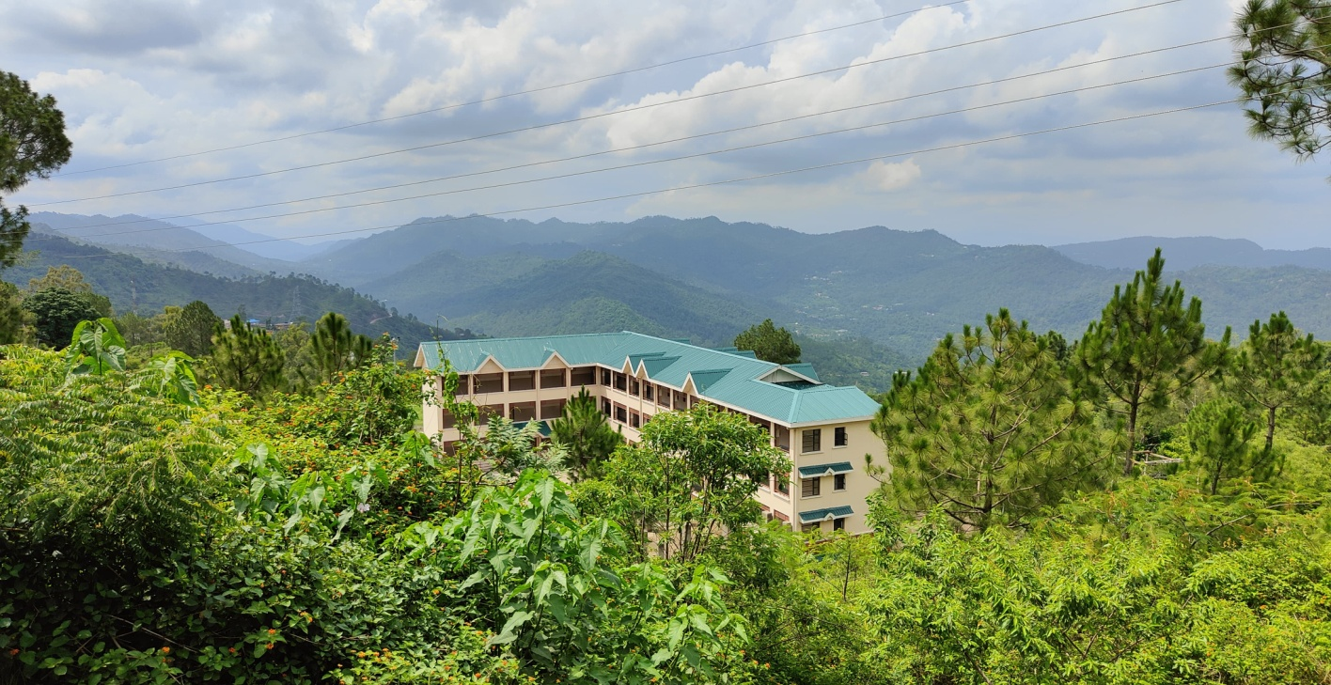
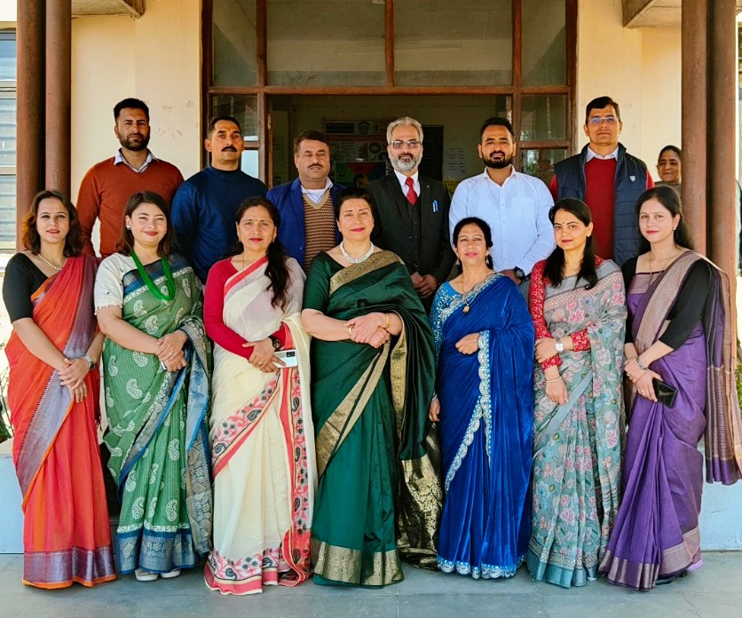
Tel and Fax: 01795-278777 & 278244
e-mail:gcdiggal-hp@nic.in
gcdiggal@rediffmail.com Website: www.gdcdiggal.in
Dr. Harpreet Kaur (Principal)

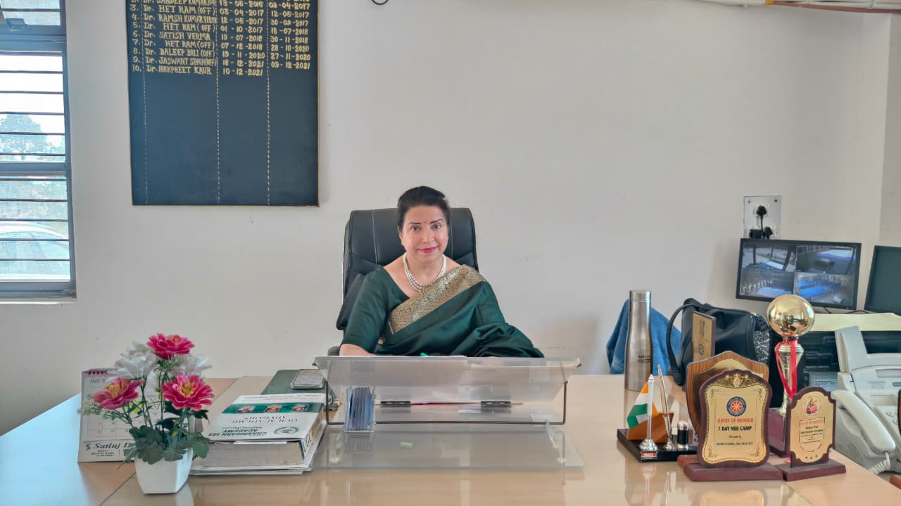
Dr. Harpreet Kaur (Principal)
TEACHING FACULTY

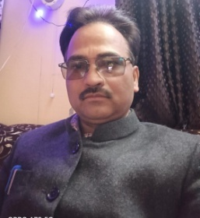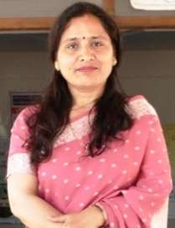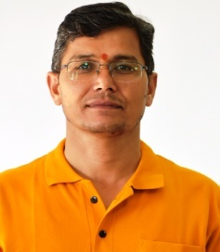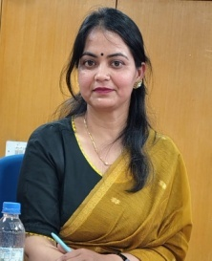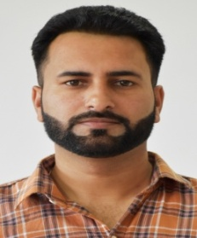
Dr. Het Ram Dr. Sudershna Sharma Mr. Dharmender Kumar Dr. Sunita Sharma Dr. Naresh Kumar
(Music) (Mathematics) (History) (Hindi) (Commerce)

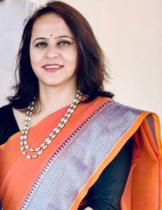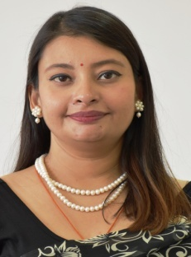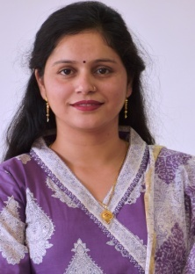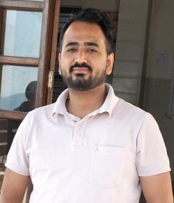
Ms. Mamta Sharma Dr. Milanpreet Ms. Reenu Sharma Mr. Rahul
(Pol.Science) (Sociology) (Economics) (Commerce)
OFFICE/ADMINSTRATIVE STAFF
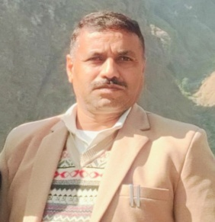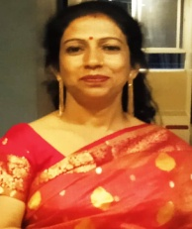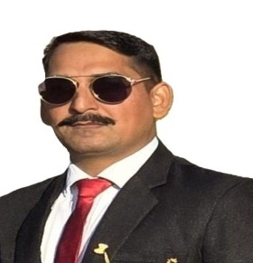
Sh. Puran Thakur Smt. Anjana Devi Sh. Sita Ram Kaushal
(Supdt. G-II) (Asstt. Librarian) (JOA)

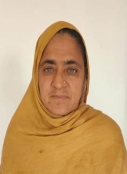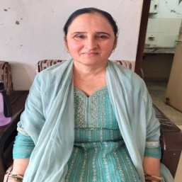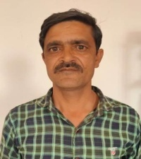
Smt. Champa Devi(Peon) Smt. Kanta Devi (Peon) Sh. Yash Pal (Peon)

CONTENTS
Sr.No. Subject
- Government Degree College Diggal : An Overview
- Admission Details : Courses Offered in the College
- Admission Schedule
- New Education Policy 2020: Semester System (2026-27)
- New Pattern of CBCS-UGC(RUSA) : The Annual Pattern(2nd & 3rd Year)
- National Cadet Corps (NCC)
- National Service Scheme (NSS)
- Arts (Humanities) Stream
- Important Guidelines for BA I Year
- Important Guidelines for BA II Year
- Roll-On Admission for Annual System Students (2025-26)
Important Guidelines for BA III Year
- Migration & Re-Appear
- Eligibility Criteria and Conditions :
Age-cum-Academic Parameters for BA/B.Com
- Admission Procedure
- Documents Required for Admission
- Reservation of Seats/Roster
- General Guidelines for Students
- Parent-Teacher Association ( The PTA Body)
- Fee & Funds
- Academic Calendar
- Administrative Committees for the Session 2026-27

Government Degree College Diggal : An Overview
This College was notified by the State Government vide notification No. EDN-A-KHA (1)-1/2014 in January 2014 to promote and uplift the standard of Higher Education in the remote and rural pocket of district Solan. The institution became functional in June 2014 and imparts UG level education in eight subjects in Arts (Humanities) stream. The college was further academically enriched in June 2015 with the addition of Commerce Stream. Nurtured in the lap of lower Shivalik Hills, the College has a picturesque location, salubrious climate and a sound academic ambience.
राजकीय महाविद्यालय दिग्गलः एक अवलोकन
जिला सोलन के दूरस्थ एवं ग्रामीण क्षेत्र में उच्चतर शिक्षा के स्तर में सुधार एवं उत्थान हेतु राज्य सरकार की अधिसूचना क्रम संख्या EDN-A-KHA(1)-1/2014 के अंतर्गत जनवरी 2014 में राजकीय महाविद्यालय दिग्गल का आरंभ किया गया। जून 2014 में यह संस्थान व्यवहारिक रूप में आया तथा यहाँ स्नातक स्तर पर शिक्षा प्रदान करने हेतु मानविकी वर्ग में आठ विषयों की कक्षाएँ कार्यान्वित हैं। जून 2015 में वाणिज्य विषय जुड़ जाने से महाविद्यालय शैक्षणिक रूप से समृद्ध हुआ। यह महाविद्यालय शिवालिक की निचली पहाड़ियों में स्थित है तथा यहाँ का शैक्षणिक माहौल अति सुरम्य एवं स्वास्थ्यप्रद है।

ADMISSION DETAILS: Courses offered in the College:
The College offers UG ( B.A.) Course in Eight Subjects in the Faculty of Arts (Humanities) and UG (B.Com) course in the stream of Commerce, as per the CBCS-UGC(RUSA). From the academic session 2016-17 the Himachal Pradesh University has adopted this new pattern of education for higher studies i.e., CBCS-UGC (RUSA). This pattern of education was in the academic session 2017-18 and was adhered in the academic session 2018-19. From the academic session 2018–19 onward, the CBCS-UGC (RUSA) pattern was restructured into an annual system in terms of both its design and format. This Annual Pattern will be followed in the session 2026-27 for only 2nd and 3rd year classes. However Himachal Pradesh University, Shimla, from the Academic Session 2026-27 is implementing New Education Policy(NEP 2020) in which the semester system is going to be introduce in 1st Year.
प्रवेश विवरण: महाविद्यालय में प्रस्तावित पाठ्यक्रम
महाविद्यालय में स्नातक स्तर पर CBCS(UGC) के अंतर्गत पारित पाठ्यक्रम में, कला संकाय(मानविकी) में आठ विषय तथा वाणिज्य स्नातक(B.Com.) वाणिज्य संकाय में प्रस्तावित किए गए हैं। शिक्षा का यह नया स्वरूप CBCS(RUSA) अकादमिक स्तर 2016-17 में हिमाचल प्रदेश विश्वविद्यालय द्वारा अपनाया गया तथा 2017-18 और आगे भी इसी स्वरूप का अनुसरण किया गया। नई वार्षिक प्रणाली अकादमिक सत्र 2018-19 से आरंभ हुई तथा 2026-27 में द्वितीय एवं तृतीय वर्ष के लिए भी यही प्रणाली लागू रहेगी। यद्यपि Himachal Pradesh University, शिमला द्वारा शैक्षणिक सत्र 2026–27 से राष्ट्रीय शिक्षा नीति 2020 लागू की जा रही है, जिसके अंतर्गत प्रथम वर्ष में सेमेस्टर प्रणाली प्रारंभ की जाएगी।
Notification

Note: I) The students of B.A./B.Com 1st year have to register on digilocker/ABC portal after they have registered themselves with the University (HPU)

ADMISSION SCHEDULE 2026-27
S. No. | Activity | Date / Time
i. | Submission of Admission Forms for Session 2026–27 | 01.06.2026 to 19.06.2026
ii. | Display of First Merit List | 20.06.2026 at 2:00 PM
iii. | Fee Deposit (First Merit List) | 21.06.2026 to 23.06.2026
iv. | Display of Second Merit List | 24.06.2026 at 11:00 AM
v. | Fee Deposit (Second Merit List) | 25.06.2026 to 27.06.2026 up to 5:00 PM
vi. | Admission Timings | 10:00 AM to 2:00 PM
vii. | Orientation of 1st Year Students | 28.06.2026 to 30.06.2026
viii. | Admission of UG 2nd and 3rd Year (On Roll Basis) | 01.06.2026 to 19.06.2026
ix. | Fee Deposit for UG 2nd and 3rd Year | 12.06.2026 to 23.06.2026
x. | Post Admission Counselling | 24.06.2026 to 30.06.2026
xi. | Regular Teaching Work for All Classes | w.e.f. 01.07.2026

NEW EDUCATION POLICY 2020
The New Pattern of NEP Semester Pattern: Implemented w.e.f. the Academic Session 2026-27 (For BA/BCom 1st year)
CURRICULUM AND CREDIT FRAMEWORK FOR UNDERGRADUATE PROGRAMMES
1. Introduction
The National Education Policy (NEP) 2020 recognises that higher education plays a crucial role in promoting human and societal well-being, and in developing India as envisioned in its Constitution—a democratic, just, socially conscious, and humane nation that upholds liberty, equality, fraternity, and justice for all. The NEP 2020 notes, “given the 21st-century requirements, quality higher education must aim to develop good, thoughtful, well-rounded, and creative individuals.”
The NEP 2020 states, “Assessments of educational approaches in undergraduate education that integrate the humanities and arts with Science, Technology, Engineering and Mathematics (STEM) have consistently shown positive learning outcomes, including increased creativity and innovation, crucial thinking and higher-order thinking capacities, problem-solving abilities, teamwork, communication skills, more in-depth learning and mastery of curricula across fields, increases in social and moral awareness, etc., besides general engagement and enjoyment of learning.”
Further, the NEP 2020 also recommends that “the undergraduate degree will be of either 3- or 4-year duration, with multiple exit options within this period, with appropriate certifications.”
In accordance with the NEP 2020, the UGC has formulated a new student-centric “Curriculum and Credit Framework for Undergraduate Programmes (UGC-CCFUGP 2022)” incorporating a flexible choice-based credit system, multidisciplinary approach, and multiple entry and exit options, which will facilitate students to pursue their career path by choosing the subject/field of their interest.
Based on the UGC-CCFUGP notified in December 2022, Himachal Pradesh University, Shimla (HPU) has developed a Curriculum and Credit Framework for Undergraduate Programmes (HPU-CCFUGP, hereafter HPU-UGP), incorporating all essential aspects of the UGC-CCFUGP to facilitate the achievement of the policy visions stated in the NEP 2020. This HPU-UGP will also apply to the professional courses not covered by other regulatory bodies.

UG Degree Programmes
The UGC-CCFUGP: 3.2.3 offers various undergraduate degree programmes for students to choose from. The different UG Degree programmes are:
i. UG Degree Programmes with Single Major: A student must secure a minimum of 50% credits in the major discipline for a 3-year/4-year UG Degree to be awarded a single major.
For example:
In a 3-year UG programme, the total number of credits to be earned is 128; a student of History with 64 credits will be awarded a Bachelor of Arts in History with a single major.
Similarly, in a 4-year UG programme, the total number of credits to be earned is 168; a student of History with a minimum of 84 credits will be awarded a Bachelor of Arts (Honours or Honours with Research) in History with a single Major.
iii. Interdisciplinary Undergraduate Programmes: The credits for core courses shall be distributed among the constituent disciplines/subjects to achieve core competence in the multidisciplinary programme.
For example:
A student opts for (a) Mathematics, (b) Economics and (c) Political Science for a UG programme. The degree for such students will be a Bachelor of Arts, awarded after a 3-year undergraduate programme. For such a candidate, to pursue a degree in the fourth year, they shall have to choose only one of the disciplines (A, B or C) in which they have studied 6 DSCs and 5 DSEs in the first three years. The degree will be awarded a Bachelor of Arts (Honours or Honours with Research) in Mathematics (if chosen Mathematics) for a 4-year undergraduate programme.
iv. Multidisciplinary Undergraduate Programmes: For students pursuing a multidisciplinary programme of study, the credits for core courses will be distributed across various broad disciplines, including Life Sciences, Physical Sciences, Mathematical and Computer Sciences, Data Analysis, Social Sciences, and Humanities.

For example:
A student who opts for a UG programme in Arts will have the total credits to core courses distributed across (a) History (b) Hindi and (c) Sociology disciplines. The Degree will be awarded as a Bachelor’s in Arts for a 3-year UG programme. For such a candidate, to pursue a Degree in the fourth year, he/she shall have to choose only one of the disciplines (either A, B or C) in which he/she has studied at least 6 DSCs and 5 DSEs of Core/Major courses in the first three years. The degree awarded will be Bachelor of Arts (Honours/ or Honours with Research) in History (if chosen History) for a 4-year UG Programme.
Eligibility for the UG Programmes
a. A student who has passed 12th standard or equivalent examination in any stream from a recognised institution (UGC-CCFUGP: 3.2.3).
b. Admission to the 3-year/4-year UG programme will be based on the preference of the Major, if any. In case a student does not want to opt for any major in the 3-year programmes/they will be admitted based on their preferences for subject combinations.
c. Admission to a discipline-specific course or major will be subject to the availability of the subject and the capacity of the college/department/centre.
d. No student shall be eligible for admission to a Programme in any discipline unless She/He fulfils the prerequisites of courses as fixed by the university.
Reservation
The statutory reservation policy of the Government of Himachal Pradesh shall be followed in the selection of eligible candidates for admission.
Academic Bank of Credits (ABC)
The HPU-UGP is directly connected to the Academic Bank of Credit (ABC) as notified by the UGC. All credits a student earns at the end of an examination in HPU-UGP will be deposited in the ABC by the university.
As such, a student under HPU-UGP must register for the ABC as notified by the regulatory agencies.
Duration for Award of UG Certificate, UG Diploma and Degree
The UG Programmes will be of either 3 or 4-year duration with appropriate certifications and exits, such as:
i. UG Certificate after completing 1 year (2 semesters) of study in the chosen fields of study with 44 credits, including four credits in I/AP/CI or work-based vocational course(s) offered during winter/or summer term.
ii. UG Diploma after 2 years (4 semesters) of study with 86 credits.
iii. 3-Year Bachelor’s Degree after successful completion of three years (6 semesters) with 128 credits.
iv. 4-Year Bachelor’s Degree (Honours) after successful completion of four years (eight semesters) with 168 credits.
v. 4-Year Bachelor’s Degree (Honours with Research) after successful completion of four years (eight semesters) with a Research Project or Dissertation under the guidance of an eligible regular faculty member, securing 168 credits, out of which 12 credits will be for the Research Project or Dissertation.
vi. Students will be permitted to take a break from the study during the period of study, but the total duration of completing the programme shall not exceed 7 years.
It should be noted that any certificate/diploma/degree is awarded only if the student clears (i.e., passes) all the required courses (papers) up to that point in time.
Note: College/CDOE/Department/HPU-DES will decide whether to offer a 3-year or 4-year undergraduate programme before the academic session starts. However, the 4-Year Bachelor’s Degree Programme may be considered a preferred option, as it would provide an opportunity to experience the full range of holistic and multidisciplinary education(vide UGS letter no 27-3/2023(CU)dated 28th March, 2023).

Change of Programme
The students who wish to change programmes in the 2nd year (or third semester) shall be eligible only for the 3-year B.A. programme (Multidisciplinary), subject to availability of seats and the Major programme in the College and earning of additional credits (8 each in each of the two core Major disciplines). Two courses of any one discipline studied in the first two semesters will be treated as a Minor. The remaining 16 credits shall be earned from a single Minor discipline.
Stage / Aspect | Exit Point | Award | Credits Required | Re-entry / Progression Rule
Year 1 | After 2 semesters | UG Certificate | 44 credits | Can re-enter later in same programme (subject to seat availability)
Year 2 | After 4 semesters | UG Diploma | 86 credits | Can re-enter later in same programme only
Year 3 | After 6 semesters | Bachelor’s Degree | 128 credits | Cannot re-enter 4th year; must apply for Master’s (1st year)
Year 4 | After 8 semesters | Bachelor’s Degree (Honours) | 168 credits | Eligible for 2nd year of Master’s programme
Year 4 (Research Track) | After 8 semesters + Research | Bachelor’s Degree (Honours with Research) | 168 credits (including 12 research credits) | Eligible for direct PhD (minimum 75% marks required)

Condition | Details
Entry/Exit Flexibility | Entry/re-entry in odd semesters, exit after even semesters
Multiple Attempts | Students can exit and re-enter multiple times
Seat Availability | Admission depends on availability; 10% extra seats may be added
Same Programme Rule | Re-entry allowed only in the same programme (after Year 1/2 exit)
Curriculum Update | Students must follow latest syllabus upon re-entry
Lateral Entry | Students from other universities can join based on merit + seat availability
Award Condition | Certificate/Diploma/Degree awarded only after passing all required courses

- Students who secure 75% or more marks in the first three years shall be eligible for a 4-Year UG Degree (Honours with Research).

- H P University 8 Migration Students pursuing their 3-year Undergraduate programme through the regular mode (i.e., a student from any college affiliated with H.P. University) can transfer their admission to CDOE at any point during a semester. Such a student, however, shall have to pay the complete Semester fee of the concerned semester as well, irrespective of the duration of the semester gone by. Students pursuing their 3-year Undergraduate programme from CDOE can be migrated or admitted as regular students to colleges against vacant seats at the beginning of the semesters.

- Inter-Institution Mobility The HPU-UGP enables students to engage in inter-institutional mobility, both for incoming and outgoing students. For this, HPU will take into account the credits that the student has in their ABC. For an incoming student, the following should be observed: a. b. c. 16. The entry is subject to the availability of seats in the concerned discipline. The student must fulfil all the academic prerequisites of the relevant discipline. HPU will award a degree to a student only when the student has completed at least 60% of the credits for core courses offered by HPU.

Programme Structure
Semester A semester comprises 90 working days, and the academic calendar is divided into two semesters. Curriculum and Credit Framework for Undergraduate Programmes H P University 9 Winter and Summer terms will be notified separately with a vacation schedule. I/A/P/C/or work-based vocational education, field-based learning, and training will be carried out during the winter and summer terms. Regular courses may also be offered during the winter or summer terms in a fast-track mode, enabling students to complete additional coursework and reduce backlogs. Arrangements may be made for courses to be offered in the winter/or summer terms, depending on the availability of faculty and the number of students.

Credit Requirements
The minimum credit requirements of each category of courses for 3-Year and 4-Year Bachelor's Programmes (Honours or Honours with Research) are given in Table 1
Sr. No. | Category of Courses | 3-Year UG (Credits) | 4-Year UG (Credits)
1 | Major (Core) | 60 | 80
2 | Minor Stream | 24 | 32*
3 | Multidisciplinary | 9 | 9
4 | Ability Enhancement Courses (AEC) | 8 | 8
5 | Skill Enhancement Courses (SEC) | 9 | 9
6 | Value Added Courses (common for all UG) | 6–8 | 6–8
7 | Internship/Apprenticeship/Field Project | 2–4 | 2–4
8 | Research Project/Dissertation | — | 12
Total |  | 128 | 168
* Refers to the UG programme with a single Major and Minor
Note: Honours students not undertaking research will do three courses for 12 credits instead of the Research Project/Dissertation.

Curriculum and Credit Framework for UG Programmes(1st and 2nd Semester)
Himachal Pradesh University

Course & Academic Level | Semester | Discipline Specific courses -Core (DSC)  Subject  A & B  Credit 4 | Discipline  Specific Elective-DSE  Credit 4 | Minor Courses  Subject  C (MC)  Credit 4 | Multidisciplinary Courses (MDC) Credit 3 | Skill Enhancement Courses  SEC  Credit 3 | Ability Enhancement Courses  AEC  Credit 2 | Internship/ Apprenticeship/ project/community Outreach  I/A/P/C  Credit 4 | Value Added Courses  (VAC)  Credit2 | Total Credit
100-199 introductory  Foundational Level courses | 1st  Semester | Subject A (DSC A1)  Subject B (DSC B1) |  | Subject C (MC1) | MDC1 | SEC1 | AEC1 |  |  | 20
100-199 introductory  Foundational Level courses | 2nd  Semester | Subject A (DSC A2)  Subject B (DSC B2) |  | Subject C (MC2) | MDC2 | SEC2 |  | I/A/P/C-1 | VAC1 | 24
TOTAL CREDIT |  |  |  |  |  |  |  |  |  | 44

- Level 4.5 Exit 1 Student on exit will be awarded Undergraduate Certificate (in the Field of Study) after securing 44 credits in Semester I and II. 44

Important Instruction
- The prescribed credit weightage includes Lecture, Tutorial, and Practical components.
- In the first semester, students will be offered three different subjects within the same stream: A, B, and C (Core and Minor are provided here for illustrative purposes only).
- At the end of the second semester, each student may choose one of two programmes: the Multi Disciplinary/Interdisciplinary or Single Core Discipline (Major) programme. The student choosing the latter will be required to give his/her Major and Minor at the end of the second semester. Such choices, including DSCs made at the end of the second semester, shall remain in effect until the VI semester.
- Additional Seats: The Colleges may create 10% extra seats over and above the sanctioned strength to accommodate the request for a change of major. Any unfilled or vacant seats may be filled with those seeking a change of Major. Preference will be given to those with the highest CGPA and no arrears in the first year/semester.
- The DSCs of another discipline for the first two semesters of students who opt for Major programmes will be treated as Minors.
- A DSC offered in one discipline will be treated as a Minor by another. Students can choose Minor Courses from two different subjects, but must earn a minimum of 12 credits in each.
- MDCs must be selected from a broad discipline/pool of MDCs other than Major and Minor subjects.
- AEC/VAC/SEC-3 should be chosen from a pool of courses. Every discipline shall provide these courses, some of which will be offered discipline-specific, while the rest can be open to students of all other disciplines. However, the two SECs (SEC-1 & SEC-2) must be chosen from the discipline-specific (Core and Minor).
- A maximum of two language courses can be opted for as Core and Minor. AECs should be in a language other than what is studied in DSCs/Minors.
- I/A/P/C will be determined at the end of the first semester to enable students to carry out some I/A/P/C activities during winter vacation.
- To pursue an Honour degree in the 4th year, students will have to choose only one discipline in both semesters, in which s/he have studied 6 DSCs and 5 DSEs in the first three years.
- A student who secures 75% or more marks in aggregate till semester 6 (up to a 3-year degree) shall be eligible for a 4-year degree Honours with Research, provided HPU has approved the college to offer it.
- One course per semester (DSC/Minor/MDC/SEC/etc) from a subject offered in two (or more) different programs (e.g. BCA and BSc/ BPA and BA/ BFA and BA/ Shastri and BA/etc) must be the same.
- Students in the BA programmes can opt for only one DSC each from the Bachelor of Performing Arts (Dance, Music, Vocal & Instrument/Tabla/ etc.) and the Bachelor of Fine Arts (Painting/Applied Arts/Sculpture/ etc.).
- Major and Minor shall be awarded on fulfilment of the following conditions: For Major, 64 credits in a 3-year & 84 credits in a 4-year UG programme in a single Major Discipline. For Minor 28 credits in 4-year UG programme in a single Minor Discipline
- The Dissertation and Project will start in the VII semester. However, the evaluation and assessment will be conducted in both the VII and VIII semesters.

*As this scheme is being introduced for the first time, it is subject to modifications. Any changes applied in subsequent years after admission to the 1st Year will be retrospectively applicable.

ARTS(HUMANITIES)STREAM: B.A. 1st and 2nd Semester (2026-27)
Curriculum and Subject Combination offered
Subject A  DSC 1 | Subject B  DSC2 | Subject C  MC1 | MDC (Select any 1) | SEC | AEC (Only 1st Sem) | I/A/P/C | VAC
Hindi | History | Pol. Science | Sociology/Music/Maths/Eco | Select anyone from Subject A, B or C | English | only in 2nd Semester | only in 2nd Semester
Pol. Science | History | Sociology | Music/Maths/Eco | Select anyone from Subject A, B or C | Eng/Hindi | only in 2nd Semester | only in 2nd Semester
History | Sociology | Hindi | Music/Maths/Eco | Select anyone from Subject A, B or C | English | only in 2nd Semester | only in 2nd Semester
Sociology | Hindi | History | Music/Maths/Eco | Select anyone from Subject A, B or C | English | only in 2nd Semester | only in 2nd Semester
Economics | Maths | English | Music/Sociology | Select anyone from Subject A, B or C | Hindi | only in 2nd Semester | only in 2nd Semester
Music | Pol. Science | Hindi | Sociology/Maths/Eco | Select anyone from Subject A, B or C | English | only in 2nd Semester | only in 2nd Semester
Mathematics | Economics | Pol.Science | Sociology/Music | Select anyone from Subject A, B or C | Eng/Hindi | only in 2nd Semester | only in 2nd Semester
English | Economics | Music | Sociology/Maths | Select anyone from Subject A, B or C | Hindi | only in 2nd Semester | only in 2nd Semester
Pol.Science | Hindi | Sociology | Maths/Eco/Music | Select anyone from Subject A, B or C | English | only in 2nd Semester | only in 2nd Semester
Hindi | Economics | Pol.Science | Sociology/Music/Maths | Select anyone from Subject A, B or C | English | only in 2nd Semester | only in 2nd Semester

- Note: MDCs must be selected from a broad discipline/pool of MDCs other than major and minor subjects and must not have studied that course at the 12th level.

Programme Structure for B.Com (Pass Course) with Commerce as core subject
Sr. No. | Course Code | Title of the Course | Category of Courses | Teaching Hours per Week  (L + T + P) | SEE  (Semester End Exam) | CIE  Continuous Internal Evaluation | Total Marks | Credits
1 | B.C.101 | Business Organization & Management | DSC - I | 4+0+0 | 70 | 30 | 100 | 4
2 | B.C.102 | Financial Accounting-I | DSC - II | 4+0+0 | 70 | 30 | 100 | 4
3 | B.C.103 | Business Law | MC - I | 4+0+0 | 70 | 30 | 100 | 4
4 | B.C. MDC - I | General Management (GE) | MDC - I | 3+0+0 | 50 | 25 | 75 | 3
5 | B.C.104 | E-Commerce | SEC - I | 3+0+0 | 50 | 25 | 75 | 3
6 | — | To be chosen from the basket of languages | AEC - I | 2+0+0 | 35 | 15 | 50 | 2
Sub–Total (A): SEE = 345, CIE = 155, Total = 500, Credits = 20
Sr. No. | Course Code | Title of the Course | Category of Courses | Teaching Hours per Week  (L + T + P) | SEE | CIE | Total Marks | Credits
7 | B.C.105 | Principles of Marketing | DSC - III | 4+0+0 | 70 | 30 | 100 | 4
8 | B.C.106 | Financial Accounting-II | DSC - IV | 4+0+0 | 70 | 30 | 100 | 4
9 | B.C.107 | Company Law | MC - II | 4+0+0 | 70 | 30 | 100 | 4
10 | B.C. MDC - II | Business Environment | MDC - II | 3+0+0 | 50 | 25 | 75 | 3
11 | B.C.108 | Entrepreneurship and Venture Creation | SEC - II | 3+0+0 | 50 | 25 | 75 | 3
12 | — | Environment-related Courses (As prepared by the Department of Env. Science) | VAC - I | 2+0+0 | 35 | 15 | 50 | 2
13 | — | As per the guidelines of the University* | I/A/P/C* | 0+0+2* | — | 50* | 50* | 2*
Sub–Total (B): SEE = 345, CIE = 205*, Total = 550*, Credits = 2

NEP 2020: From 2026-27
Revised Structure/Scheme for Paper Setting, Assessment, and Evaluation for Discipline Specific Core (DSC), Discipline Specific Elective (DSE), Minor Course (MC), Multidisciplinary Course (MDC), Skill Enhancement Course (SEC), Ability Enhancement Course (AEC), Value Addition Course (VAC) & Add-on Course (AOC)
Name of Course | Credits | Structure of Each Paper | Division of Marks | Paper Pattern for End-Semester Examination | Duration of End Sem Exam
DSC, DSE, and MC | 4 | - There shall be four Sections/ Blocks (I, II, III, IV) in the syllabus of each paper.  - Each Section/Block preferably may have 4 units. | - The Evaluation shall be Continuous and Comprehensive Evaluation (CCE).  - Each Paper in a Course shall be of 100 marks and divided as follows:  Internal Assessment- 30 Marks  End Semester Exam- 70 Marks  Internal Assessment:  Attendance- 05 Marks  Class Test- 15 Marks  Assignments & Presentations- 10 Marks | There will be 5 Parts (A, B, C, D, E), and the examiner shall set 9 questions in total from all the Sections/Blocks (I, II, III, IV) in total and each question shall carry 14 marks.  - Part A will have 2 questions from Section/Block I of the syllabus and students have to attempt any one.  - Part B will have 2 questions from Section/Block II of the syllabus and students have to attempt any one.  - Part C will have 2 questions from Section/Block III of the syllabus and students have to attempt any one.  - Part D will have 2 questions from Section/Block IV of the syllabus and students have to attempt any one.  - Part E will have 10 short answer questions from all the Sections/Blocks of the syllabus (I, II, III, IV) and the student shall have to attempt 7 in total carrying 2 Marks each. | 3 hrs
MDC & SEC | 3 | - There shall be three Sections/ Blocks (I, II, III) in the syllabus of each paper.  - Each Section/Block preferably may have 3 units. | - The Evaluation shall be Continuous and Comprehensive Evaluation (CCE).  - Each Paper in a Course shall be of 75 marks and divided as follows:  Internal Assessment- 25 Marks  End Semester Exam- 50 Marks  Internal Assessment:  Attendance- 05 Marks  Class Test- 10 Marks  Assignments & Presentations- 10 Marks | There will be 4 Parts (A, B, C, D), and examiner shall set 7 questions in total from all the Sections/Blocks (I, II, III) in total.  - Part A will have 2 questions of 12 Marks each from Section/Block I of the syllabus and students have to attempt any one.  - Part B will have 2 questions of 12 Marks each from Section/Block II of the syllabus and students have to attempt any one.  - Part C will have 2 questions of 12 Marks each from Section/Block III of the syllabus and students have to attempt any one.  - Part D will have 10 short answer questions of 2 Marks each from all three Sections/Blocks (I, II, III) of the syllabus, and the student shall have to attempt 7 in total. | 2 hrs
AEC, VAC, and AOC | 2 | - There shall be two Sections/ Blocks (I, II) in the syllabus of each paper.  - Each Section/Block preferably may have 2 units. | - The Evaluation shall be Continuous and Comprehensive Evaluation (CCE).  - Each Paper in a Course shall be of 50 marks and divided as follows:  Internal Assessment- 15 Marks  End Semester Exam- 35 Marks  Internal Assessment:  Attendance- 05 Marks  Class Test, Assignments & Presentations- 10 Marks  *The scheme for NCC/NSS/ Yoga/ Sports etc. will be notified separately. | There will be 3 Parts (A, B, C) and examiner shall set 5 questions in total from all the Sections/Blocks (I, II) in total.  - Part A will have 2 questions of 10 Marks each from Section/Block I of the syllabus and students have to attempt any one.  - Part B will have 2 questions of 10 Marks each from Section/Block II of the syllabus and students have to attempt any one.  - Part C will have 7 questions of 3 Marks each from both the Sections/Blocks (I, II) of the syllabus, and the students have to attempt any 5 questions. | 1.5 hrs
Note: A minimum of 75% attendance in both theory and practical subjects is mandatory to be eligible for the End Semester Examination.

Revised Structure/Scheme for Paper Setting, Assessment, and Evaluation for Practical Courses
Name of Course | Credits | Structure of Each Paper | Division of Marks | Paper Pattern for End-Semester Examination | Duration of End Sem Exam
Courses where L T P is kept 3 0 1  Lecture-3  Tutorial-0  Practical-1  (For the Theory Course having 4 Sections/ Blocks (I, II, III, IV) | 4 | - There shall be four Sections/ Blocks (I, II, III, IV) in the syllabus of each paper.  - Each Section/Block preferably may have 4 units. | - The Evaluation shall be Continuous and Comprehensive Evaluation (CCE).  - Each Paper in a Course shall be of 100 marks and divided as follows:  End Semester Theory Exam- 50 Marks  End Semester Practical Exam- 20 Marks (Breakup of Marks):  Performance- 10 Marks  Viva-Voce- 05 Marks  File- 05 Marks  Internal Assessment- 30 Marks (Breakup of Marks):  Attendance- 05 Marks  Class Test- 10 Marks  Assignments & Presentations- 10 Marks  Internal Assessment of Practical- 05 Marks  *Duration of End Semester Practical will be 3 Hours | End Semester theory paper shall be of 50 Marks. There will be 5 Parts (A, B, C, D, E), and the examiner shall set 9 questions in total from all the Sections/Blocks (I, II, III, IV) in total.  - Part A will have 2 questions of 10 Marks each from Section/Block I of the syllabus and students have to attempt any one.  - Part B will have 2 questions of 10 Marks each from Section/Block II of the syllabus and students have to attempt any one.  - Part C will have 2 questions of 10 Marks each from Section/Block III of the syllabus and students have to attempt any one.  - Part D will have 2 questions of 10 Marks each from Section/Block IV of the syllabus and students have to attempt any one.  - Part E will have 7 short answer questions of 2 Marks each from all the four Sections/Blocks of the syllabus (I, II, III, IV), and the student shall have to attempt 5 in total. | 3 hrs
(For the Theory Course having 3 Sections/ Blocks (I, II, III) | 4 | - There shall be three Sections/ Blocks (I, II, III) in the syllabus of each paper.  - Each Section/Block preferably may have 3 units. | - The Evaluation shall be Continuous and Comprehensive Evaluation (CCE).  - Each Paper in a Course shall be of 100 marks and divided as follows:  End Semester Theory Exam- 50 Marks  End Semester Practical Exam- 20 Marks (Breakup of Marks):  Performance- 10 Marks  Viva-Voce- 05 Marks  File- 05 Marks  Internal Assessment- 30 Marks (Breakup of Marks):  Attendance- 05 Marks  Class Test- 10 Marks  Assignments & Presentations- 10 Marks  Internal Assessment of Practical- 05 Marks  *Duration of End Semester Practical will be 3 Hours | End Semester theory paper shall be of 50 Marks. There will be 4 Parts (A, B, C, D), and the examiner shall set 7 questions in total from all the Sections/Blocks (I, II, III) in total.  - Part A will have 2 questions of 12 Marks each from Section/Block I of the syllabus and students have to attempt any one.  - Part B will have 2 questions of 12 Marks each from Section/Block II of the syllabus and students have to attempt any one.  - Part C will have 2 questions of 12 Marks each from Section/Block III of the syllabus and students have to attempt any one.  - Part D will have 10 short answer questions of 2 Marks each from all the four Sections/Blocks of the syllabus (I, II, III), and the student shall have to attempt 7 in total. | 3 hrs
Music (Instrument)  where L T P is kept 2 0 2  Lecture-2  Tutorial-0  Practical-2 | 4 | - There shall be two Sections/ Blocks (I, II) in the syllabus of each paper.  - Each Section/Block preferably may have 2 units. | - The Evaluation shall be Continuous and Comprehensive Evaluation (CCE).  - Each Paper in a Course shall be of 100 marks and divided as follows:  End Semester Theory Exam- 35 Marks  End Semester Practical Exam- 35 Marks (Breakup of Marks):  Performance- 25 Marks  Written/Viva-Voce- 10 Marks  Internal Assessment (Theory+ Practical)- 30 Marks (15+15) (Breakup of Marks):  Attendance- 05 Marks  Class Test- 05 Marks  Assignments & Presentations- 05 Marks  Internal Assessment of Practical- 15 Marks  *Duration of End Semester Practical will be 1.5 Hours | There will be 3 Parts (A, B, C) and examiner shall set 5 questions in total from all the Sections/Blocks (I, II) in total.  - Part A will have 2 questions of 10 Marks each from Section/Block I of the syllabus and students have to attempt any one.  - Part B will have 2 questions of 10 Marks each from Section/Block II of the syllabus and students have to attempt any one.  - Part C will have 7 questions of 3 Marks each from both the Sections/Blocks (I, II) of the syllabus, and the students have to attempt any 5 questions. | 1.5 hrs (Theory)  1.5 hrs (Practical)
Courses where the division of the credits  L T P is kept 0 0 3  Lecture-0  Tutorial-0  Practical-3 | 3 | Not Applicable | - The Evaluation shall be Continuous and Comprehensive Evaluation (CCE).  - Each Paper in a Course shall be of 75 marks and divided as follows:  End Semester Practical Exam- 50 Marks (Breakup of Marks):  Performance- 35 Marks  Written/Viva-Voce- 15 Marks  Internal Assessment (Practical)- 25 Marks (Breakup of Marks):  Attendance- 05 Marks  Class Test/ Mid-Sem Evaluation- 10 Marks  Assignments & Presentations/ File Record- 10 Marks  *Duration of End Semester Practical will be 1.5 Hours | Not Applicable
Note: A minimum of 75% attendance in both theory and practical is mandatory to be eligible for the End Semester Examination.
There are two types of Degree offered in the new Education Policy 2020
- Type 1: Single Core Discpline (Major)with Minor(in which the student will complete the degree with only one Major subject)
- Type 2: Multidisciplinary/Interdisciplinary (in which the student will complete the degree with multiple subject without any major)

SEMESTER WISE COURSE PLAN
AN EXAMPLE OF SEMESTER WISE COURSE PLAN FOR A SINGLE CORE DISCIPLINE (MAJOR)WITH MINOR
Sem | Course | Category | Credits | Remarks
I | Core | 1 History | 4 | To be selected from Courses offered by History Department
I | Core | 1 Economics | 4 | To be selected from Courses offered by Economics Department
I | Core | 1 Political Science | 4 | To be selected from the Courses offered by Political Science Department
I | MD | 1 Multidisciplinary Course | 3 | To be selected from Multidisciplinary Course offered by various departments. This has to be different from major and minor
I | SEC | 1 Skill Enhancement Course | 3 | To be selected from list of the Skill Enhancement Courses offered for the semester
I | AEC | 1 Ability Enhancement Course | 2 | To be selected from Ability Enhancement Courses-English, Sanskrit or Hindi
 |  | Total | 20
Sem | Course | Category | Credits | Remarks
II | Core | 1 History | 4 | To be selected from Courses offered by History Department
II | Core | 1 Economics | 4 | To be selected from Courses offered by Economics Department
II | Core | 1 Political Science | 4 | To be selected from the Courses offered by Political Science Department
II | MDC | 1 Multidisciplinary Course | 3 | To be selected from Multi-disciplinary Courses offered by various departments for the semester
II | SEC | 1 Skill Enhancement Course | 3 | To be selected from list of the Skill Courses offered for the semester
II | IAPC | 1 IAPC/or Vocational Course | 4 | To be selected from list of the IAPC activities/or Vocational Courses offered for the semester by the college as per HPU guidelines
II | VAC | 1 Value-Addition Course | 2 | To be selected from Value Addition Courses offered for the semester
 |  | Total | 24
Sem | Course | Category | Credits | Remarks
III | Major | 2 History DSC Courses | 8 | To be selected from Courses offered by Parent Department
III | Minor | 1 Political Science | 4 | To be selected from the Major Courses offered by Political Science Department
III | MDC | 1 Multidisciplinary Course | 3 | To be selected from Multi-disciplinary Courses offered by various departments for the semester
III | SEC | 1 Skill Enhancement | 3 | To be selected from list of the Skill Courses offered for the semester
 |  | Total | 22

Sem | Course | Category | Credits | Remarks
IV | Major | 2 History DSC Courses | 8 | To be selected from Courses offered by Parent Department
IV | Major | 1 History DSE Course | 4 | To be selected from Courses offered by Parent Department
IV | Minor | 1 Political Science | 4 | To be selected from the Major Courses offered by Political Science Department
IV | AEC | 1 Ability Enhancement Course | 2 | To be selected from Ability Enhancement Courses-English, Skt. or Hindi
IV | VAC | 1 Value-Added Course | 2 | To be selected from Value Added Courses offered for the semester
 |  | Total | 20
Sem | Course | Category | Credits | Remarks
V | Major | 2 History DSC Courses | 8 | To be selected from Courses offered by Parent Department
V | Major | 2 History DSE Courses | 8 | To be selected from Courses offered by Parent Department
V | Minor | 1 Political Science Course | 4 | To be selected from the Major Courses offered by Political Science Department
V | AEC | 1 Ability Enhancement Course | 2 | To be selected from Ability Enhancement Courses-English, Sanskrit or Hindi
 |  | Total | 22
Sem | Course | Category | Credits | Remarks
VI | Major | 3 History DSC Courses | 12 | To be selected from Courses offered by Parent Department
VI | Major | 2 History DSE Courses | 8 | To be selected from Courses offered by Parent Department
 |  | Total | 20

Semester-wise Course Plan
An example of a semester-wise course plan for Multidisciplinary/Interdisciplinary Programme
Sem | Course Category | Category | Credits | Remarks
I | Core | 1 History | 4 | To be selected from Course offered by History Department
 | Core | 1 Pol. Science | 4 | To be selected from Course offered by Pol. Science Department
 | Core | 1 Hindi | 4 | To be selected from the Course offered by Hindi Department
 | MD | 1 Multidisciplinary Course | 3 | To be selected from Multidisciplinary Course offered by various departments. This has to be different from major and minor.
 | SEC | 1 Skill Enhancement Course | 3 | To be selected from list of the Skill Enhancement Course offered for the semester
 | AEC | 1 Ability Enhancement Course | 2 | To be selected from Ability Enhancement Courses-English, Sanskrit or Hindi
 | Total |  | 20
II | Core | 1 History | 4 | To be selected from Course offered by History Department
 | Core | 1 Pol. Science | 4 | To be selected from Course offered by Pol. Science Department
 | Core | 1 Hindi | 4 | To be selected from the Courses offered by Hindi Department
 | MDC | 1 Multidisciplinary Course | 3 | To be selected from Multi-disciplinary Courses offered by various departments for the semester
 | SEC | 1 Skill Enhancement Course | 3 | To be selected from list of the Skill Courses floated for the semester
 | JAPC | 1 IAPC/or Vocational Course | 4 | To be selected from list of the IAPC activities/or Vocational Courses offered for the semester by the college as per HPU guidelines
 | VAC | 1 Value-Addition Course | 2 | To be selected from Value Addition Courses offered for the semester
 | Total |  | 24
III | Core | 1 History | 4 | To be selected from Courses offered by Parent Department
 | Core | 1 Pol. Science | 4 | To be selected from Courses offered by Parent Department
 | Minor | 1 Hindi | 4 | To be selected from the Major Courses offered by Hindi Department
 | MDC | 1 Multidisciplinary Course | 3 | To be selected from Multidisciplinary Courses offered by various departments for the semester
 | SEC | 1 Skill Enhancement Course | 3 | To be selected from list of the Skill Enhancement Course offered for the semester
 | AEC | 1 Ability Enhancement Course | 2 | To be selected from Ability Enhancement Courses-English, Sanskrit or Hindi
 | VAC | 1 Value-Addition Course | 2 | To be selected from Value-Addition Course offered for the semester
 | Total |  | 22
IV | Core | 1 History | 4 | To be selected from Course offered by Parent Department
 | Core | 1 Pol. Science | 4 | To be selected from Course offered by Parent Department
 | Core | 1 DSE (either History or Pol. Science) | 4 | To be selected from Course offered by Parent Department (History or Pol. Science)
 | Minor | 1 Hindi | 4 | To be selected from the Major Courses offered by Hindi Department
 | AEC | 1 Ability Enhancement Course | 2 | To be selected from Ability Enhancement Courses-English, or Hindi
 | VAC | 1 Value-Added Course | 2 | To be selected from Value Added Courses offered for the semester
 | Total |  | 20
V | Core | 1 History | 4 | To be selected from Courses offered by Parent Department
 | Core | 1 Pol. Science | 4 | To be selected from Courses offered by Parent Department
 | Core | 2 DSE (History or Pol. Science) | 8 | To be selected from Courses offered by Parent Department
 | Minor | 1 Hindi | 4 | To be selected from the Major Courses offered by the Hindi Department
 | AEC | 1 Ability Enhancement Course | 2 | To be selected from Ability Enhancement Courses-English, Sanskrit or Hindi
 | Total |  | 22
VI | Core | 1 History | 4 | To be selected from Courses offered by Parent Department
 | Core | 1 Pol.Science | 4 | To be selected from Courses offered by Parent Department
 | Core | 2 DSE (History or Pol. Science) | 8 | To be selected from Courses offered by Parent Department
 | Minor | 1 Hindi | 4 | To be selected from the Major Courses offered by the Chemistry Department
 | Total |  | 20
Annual System for BA/B.Com 2nd and 3rd Year
CBCS – UGC (RUSA) Annual Pattern: Implemented w.e.f. the Academic Session 2018-2019 (For BA/BCom 2nd and 3 year)

The Annual Pattern of CBCS-UGC (RUSA) was adopted for the UG Classes w.e.f. the Academic Session 2018-19 vide directions issued from the o/o the Secretary of Higher Education (HP) on dated 13th June, 2018 which were further duly endorsed from the Office of Registrar (Academic Branch) HP University, Shimla vide letter No.-7-1/2004-HPU(Acad) on dated 26thJuly,2018. .In course of executing this change of pattern (from Semester to Annual System) the following parameters came into force for the Annual System:
    - The minimum passing marks will be 40% in Aggregate. However, 35% each in Internal Assessment and Final Examinations will be compulsory.
    - A candidate failing in either one or two subjects/papers will be given compartment in that subject/papers and will be eligible for promotion to the next class. He/She will appear in the subject/papers in which he/she got the compartment. He/She will have two chances (one at the supplementary stage and one at the annual stage), available to him/her to clear his/her compartment in subjects/papers. He/she will not be awarded the degree until he/she clears all his/her courses within five years from the date of his/her admission to a particular course.

A candidate failing in three or more subjects /papers will be treated as FAIL in that year and has to repeat the entire year.
- The successful candidates will be classified on the combined results of Part–I, II & III Examinations as per the following parameters :
First Division: 60% marks or more in the Aggregate
Second Division: 50% marks but less than 60%
Third Division: Less than 50% marks in the Aggregate.
- Re-evaluation :Re-evaluation shall be applicable as per provisions of HP University Ordinance for the Annual System.
- The students shall be required to complete the degree within five years.
- Final/Annual Examinations shall be held in the month of March/April every year and the Supplementary Examinations shall be held in the month of September/October every year.
अधिक एवं नवीनत्तम जानकारियों/संशोधनों के लिए हिमाचल प्रदेश सरकार के उच्चशिक्षा विभाग, हिमाचल प्रदेश विश्वविद्यालय शिमला और विश्वविद्यालय अनुदान आयोग की निम्नलिखित वैबसाईट पर लॉगइन किया जा सकता हैः
- www.hpuniv.gov.in
- www.hpuniv.in
- www.hpuniv.hp.gov.in
- www.ugc.ac.in
- www.educationhp.org
- www.exams.hpushimla.in

National Cadet Corps (NCC):
NCC Directorate Pb, Har & HP vide their letter No. 7701/Re-org/Sm/P&C dt. 30 Dec. 2020 approved NCC troop with cadet strength of 36 SD (Boys) and 18 SW (Girls) in Govt. Degree College Diggal.
National Service Scheme (NSS)
NSS Himachal Pradesh University, Shimla (NAAC Accredited “A” grade University) O/o Programme Coordinator, NSS vide their letter No.1/2009-(Allot)/NSS/HPU:-998 on dated 3rd January, 2023, allotted NSS half unit with volunteers strength of 50 in Govt. Degree College, Diggal.
ARTS (HUMANITIES) STREAM: B.A.( Pass Course)

ARTS (HUMANITIES) STREAM: B.A.(Pass Course)

Subject Structure of B.A.II (Session 2026-27)

Year | Core Courses | Ability Enhancement  Compulsory Courses (AECC) | Skill Enhancement Courses  (SEC) | Discipline  Specific Elective (DSE) | General  Elective (GE)
B.A.II  Pass Course | English-II Hindi-1I DSC-1C DSC-1D DSC-2C DSC-2D  Total 6x6= 36 Credits | NIL | SEC-1 SEC-II  Total 2x4=08 Credits | NIL | NIL

Important Guidelines/Pattern/Scheme of Papers for B.A.III
- The Students seeking roll-on admission to B.A.III Year will have to study Two DSE Subjects, i.e, DSE-I and DSE-II (Discipline Specific Electives), based on their two DSC subjects. Whereby the two DSC Subjects opted by the students at the time of their admission to the B.A. Course in the first year will continue to remain the two DSE Subjects for them in the final year.
- The Students of III year will also continue to study two SEC Course that they had initiated from
B.A.II year of their course onwards.
c) In addition to the aforementioned three subjects the students will study two paper of Generic Elective GE-I and GE-II.

Note : (Generic Elective Course) The Generic Elective in the ﬁnal year
required to be offered by the student will be other than the two Discipline Speciﬁc Courses offered by the student.
Subject Structure of B.A.III Year (Session 2026-27)
Core Courses | Ability Enhancement Compulsory Courses (AECC) | Skill Enhancement Courses  (SEC) | Discipline Specific Elective (DSE) | General Elective (GE)
NIL | NIL | SEC-III  Total 1x4=04 Credits  SEC-1V  Total 1x4=04 Credits | DSE-1A DSE-2A  Total 2x6=12 DSE-1B DSE-2B  Total 2x6=12 | GE-1  Total 1x6=06 GE-1I  Total  1x6=06

Migration: Inter-institutional Migration (either from one college to another or from a college to ICDEOL and vice- versa) of students will be allowed as per HPU norms and will accrue only after obtaining No- Objection Certificate from both the Relieving and Receiving Institutions.
Re-Appear (2nd &3rd Year): If a student, who fulfils all the requirements for appearing in a Yearly examination, is unable to appear in the examination or to complete it on account of his/her own serious illness, accident, or on account of the death of near relative (Mother, Father, Brother and Sister), or due to the clash of dates of State or National level examinations falls on dates of the semester exams may be allowed to appear in the Yearly exam in the next Academic Year when examination for that year is due. Permission to sit in the examination will be granted by college Principal/Director on the production of a valid certificate/document from the competent authority. The college will send the names of the students to the Registration and Migration Cell for information.

Eligibility Criteria and Conditions:

- AGE: A candidate should not be more than 23 years of age (for Boys) and not of more than 25 years of age (for Girls) as on 01 July, 2026. However, for SC/ ST candidates a relaxation of three years in age is allowed.
- The Vice-Chancellor of H.P.U. may in exceptional cases/circumstances, to be recorded in writing,
give relaxation in age up to a maximum of six months to any candidate. All such cases of age relaxation of up to six months may be granted admission provisionally by the Principal and a consolidated list of all such cases will be sent for the approval of the Vice- Chancellor, HP University Shimla for every academic year.
- Relaxation in upper age limit is also available to.

Admission Procedure:

STEP-I : Every candidate seeking admission shall apply for admission on the prescribed Admission Form that is available in the college prospectus. The Admission Form should be lled legibly by each candidate in his or her own handwriting.
STEP-II : A candidate seeking admission should personally appear before the concerned Admission Committee along with the required original and certified documents and he/she must also be accompanied by Parents/Guardian at the time of admission.
STEP-III : After the approval of the Admission Form by the Admission Committee it would be forwarded to the Scrutiny Committee and finally the admission to the college would be granted on merit- basis and on the recommendation of the Principal. The Principal, however, reserves the right to disallow or cancel any admission if the conduct of the student has not been up to the mark during previous years.
STEP-IV : If the admission of the candidate is approved / recommended by the Principal, the candidate shall have to deposit the fee/ dues as per the instructions displayed on the college notice board. The number of seats is maximum 80 in each DSC subject and these seats will be filled on the Basis of Merit in each of the DSC subjects respectively. The students are advised to deposit their fee and funds within time after consulting the merit list that would be displayed on the college notice board.
STEP-V : After depositing the fee the candidate will seek the enrolment of the college as a regular student. The admission will however remain PURELY PROVISIONAL in nature unless it is approved by HP University.

Documents Required for Admission:

The candidates must submit/produce the following documents along with legibly and completely filled up Admission Form:
- Original Certificates (along with their photocopies) Matric onwards.
- Three passport size photographs.
- Original Character Certificate issued by the institution last attended (for new admissions
/fresh candidates only)
- An Affidavit issued by a Competent Authority in case of gap.
- Category Certificate for SC/ST/Specially Abled students.
- Sports and Cultural Certificates (if seeking admission under the Sports/ Cultural Quota).
- Board equivalence Certificate for the candidates who have passed 10+2 from other Board/University than the H.P.Board. (HPBOSE). All such candidates (except H.P.Board candidates) will also have to produce original Migration Certificate from Board/ University from which they have passed the previous (last) examination.
- Private students seeking admission to the College for the first time should submit recent Character Certificate issued by a Gazetted Officer/ MLA/ Pradhan of M.C./ Panchayat. (which shall be valid for six months)
- Certificate of Bonafide Himachali (For girls students who belong to
Himachal). Only girl students who are Bonafide Himachali are eligible for exemption of tuition fees.
- Copy of the Aadhar Card.
- Copy of the Pass Book of Bank Account.
Note: Submission of false information of any kind for the purpose of admission is a serious offence. Any such act will be viewed seriously and penal proceedings can be initiated against such candidates/ such offenders. The admission of such candidates shall also stand cancelled instantaneously.

Reservation of Seats: Admission to UG courses shall be open to all persons irrespective of race, creed, caste or class subject to the conditions laid down in the Roster issued/notified by the H.P.U.
Point-1 The candidates seeking admission under any category or quota mentioned in the Roster, i.e., SC, ST, Specially abled, Sports or cultural, will have to produce the original certificate, issued by a Competent Authority, of his/ her category or quota at the time of admission to get the benefit of reservation.
Point-2 The reservation roster issued/ notified by the HPU:
SPECIALLY ABLED | CULTURAL | SPORTS | SC | ST | EWS
03% | 05% | 05% | 15% | 7.5% | 10%

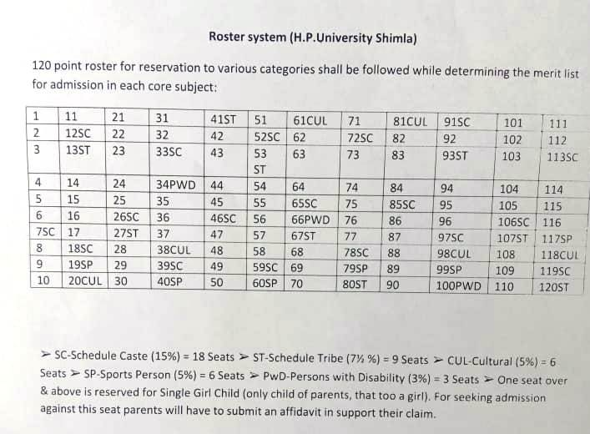
STUDENT EVALUATION SYSTEM (for B.A./B.Com 2nd and 3rd year)

UNDER-CBCS-UGC-(RUSA)-Annual System ( 2026-27) :
The Student Evaluation System under CBCS of RUSA (Annual System) has been divided into two components:

Continuous Comprehensive Annual/Final Examination Assessment (CCA)
(30 Marks: For all courses) (70 Marks: For all courses)

Continuous Comprehensive Assessment (CCA):
It includes : (i) Class Room Attendance (05 Marks): A student must attend a minimum of 75% lectures/ tutorials failing which he/ she will not be eligible for appearing in the End Semester Examination of HPU
- Mid Term Test (MTT) and a Class Test [10 + 05 = 15 Marks]
Mid –Term Test will be of 10 marks and the Class Test will be of 05 Marks for the students (in each Academic Year)
- Seminars/ Assignments/ Presentation/Tests and Tutorials (10 Marks)
The above mentioned activities will be conducted by the teachers on regular basis during the Academic Year and the students will be awarded/grade according to their performance in these class-room activities.
ANNUAL EXAMINATION: (70 MARKS)
It refers to the examination conducted by the HPU at the end of the Academic Year. The Annual Examination will be based on the whole syllabus and will be of 03 hour duration.
NOTE : (i) Only those students will be allowed to appear in the Annual Examination who have pass marks in CCA.
(ii) HPU may from time to time revise and amend (change) the regulations and curriculum after due approval of different bodies and authorities of the HP University.
GENERAL GUIDELINES FOR STUDENTS:

- Change of Subject : The students/ applicants are advised to be very careful while selecting and
filling their DSC subjects and SEC subjects. These subjects once opted will not be changed under any circumstances. The DSC-1 subject opted by the student at the time of admission in the first year will remain his/her SEC subject from 2nd and 3rd year.
- Re-Admission : The name of the student who remains absent from any class for 10 continuous days, without proper leave, shall be struck-off from the college- rolls. However, the Principal, in his/her discretion, may re- admit such student on payment of the re-admission fee along with fine. The re- admission should be taken within four days of the name being struck- off failing which he/she will not be eligible for admission. Any student whose name is struck- off for the second time in a session will not be eligible for re- admission except in exceptional circumstances.
- Leave Rules : Students applying for leave shall get their application recommended /approved from the concerned Subject Teacher. Leave up to a period of 6 days will be sanctioned by the concerned Teacher and leave for more than 6 days will be sanctioned by the Principal. Absence without leave would entail absence ne at the following rates:
- Absence per Period = Rupee1/period
- Absence from MTT-I/ MTT-II exams = Rs.50/ paper
- Notice Board and Identity Card: Every student is advised to carry his/her college identity card while coming to the institution. It is also advisable to read the notices pasted/affixed on the college Notice Board on regular basis to keep upto date information about the college activities.
- Discipline: Discipline is the key of student life and the institution expects high standards of orderliness from its pupil/subjects. The following activities will be considered as violation of the college discipline and may result in ne, expulsion or rustication, depending on the gravity of the offence:
- Indulging in acts of Ragging and Eve - teasing.
- Making noise, disturbing classes and using mobiles within the college campus.
- Damaging college furniture/ property and writing on walls, furniture and blackboards.
- Bringing outsiders to the college campus without any justifiable cause.
- Any student found smoking or consuming other tobacco products in the college premises will be dealt sternly with.
Note: A student found guilty of misconduct shall not be eligible for prizes, scholarships, fee- concession or membership of the CSCA (College Student Central Association), Sports Council or other important bodies of the College.

PARENT- TEACHER ASSOCIATION (The PTA Body):
Since 2014, the college has framed a PTA for co-ordinated efforts of Parents and College Administration and for the betterment of the institution thereof. Fresh PTA will be constituted in the month of August 2021 as per the PTA norms laid down by the Education Department of H.P. Government. The Annual PTA fee for the session 2023-24 shall finally be decided after by PTA General House.

Academic Calendar 2026-27

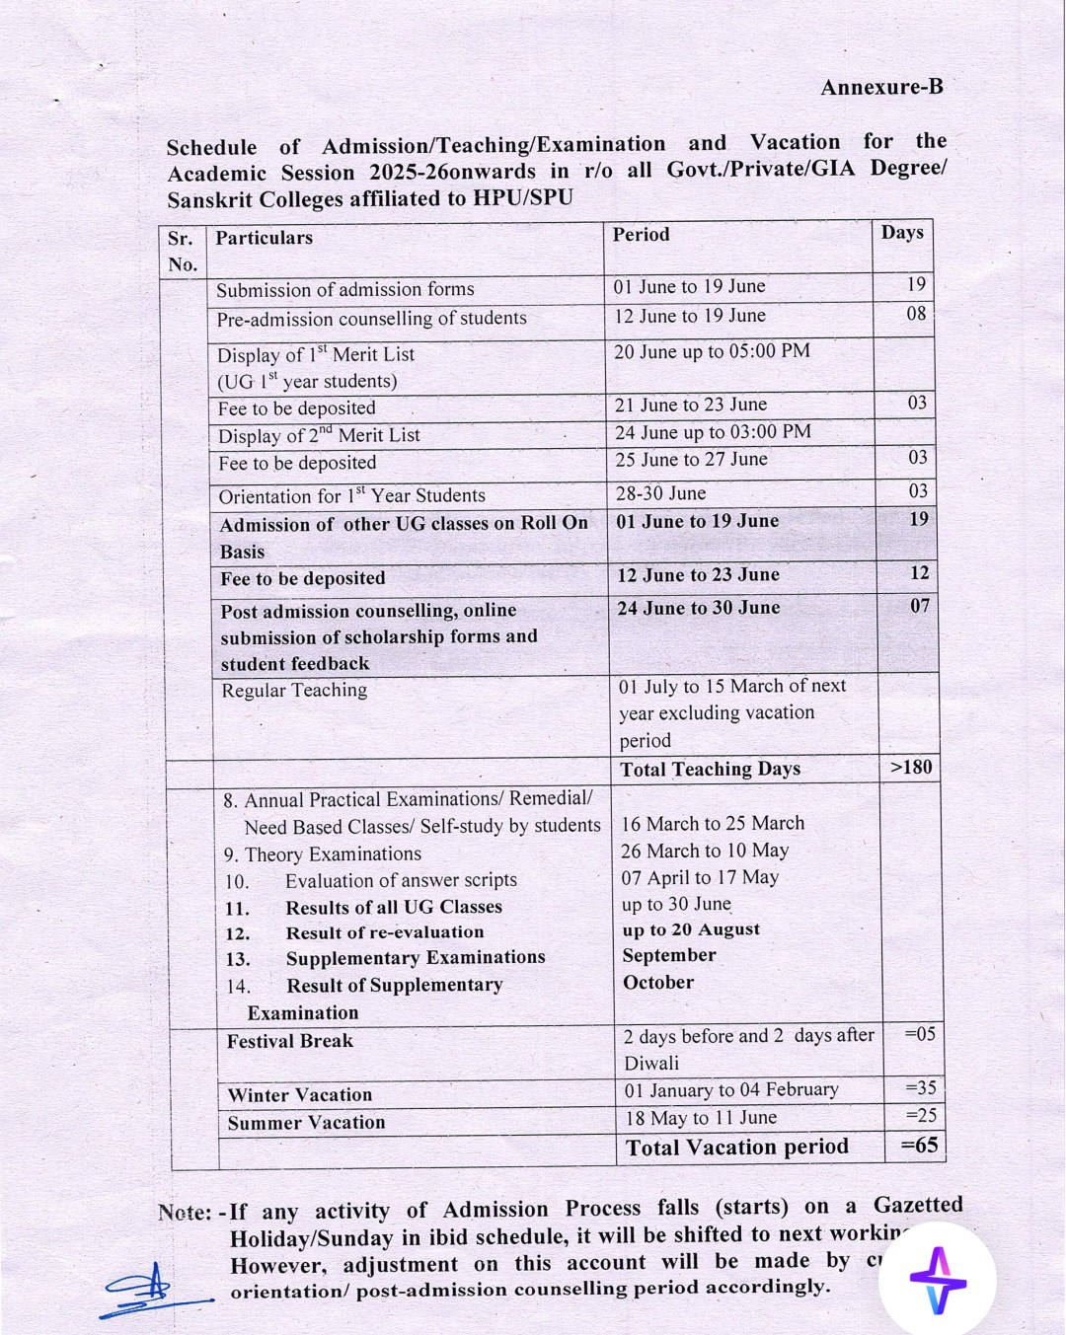

FEE and FUNDS
DETAIL OF FEE STRUCTURE FOR UNDER GRADUATE CLASSES(Annual System)

SR. No. | Name of Fund | Amount  Rs | Periodicity
1. | Admission fee | 25-00 | Annual
2 | Re-Admission Fee first time | 100-00
3 | Re-Admission Fee second time | 200-00
4 | Late Admission Fee | 10-00 | Per day
5. | Tuition Fee Rs .50 (PM for Boys and Non-Himachali Girls) | 600-00 | Annual
6 | Continuation Fee (for 2nd & 3rd year students) | 10-00
7 | HP Youth Welfare Fund | 100-00 | Annual
8 | HPU Sports Fee | 100-00 | Annual
9 | HPU Holiday Home fee | 1-00 | Annual
10 | University Development Fund (General Students) | 500-00 | Annual
10 | University Development Fund (BPL/IRDP Students) | 250-00 | Annual
11 | CSCA Fund | 10-00 | Annual
12 | Red Cross Fund | 40-00 | Annual
13 | Sports Fund | 240-00 | Annual
14 | Building Fund | 120-00 | Annual
15 | Amalgamated Fund | 300-00 | Annual
16 | Rovers & Rangers Fund | 60-00 | Annual
17 | Book Replacement | 25-00 | Annual
18 | House Exam fees | 50-00 | Annual
19 | College Magazine | 50-00 | Annual
20 | Identity Card (First Time) | 10-00 | Annual
21 | Identity Card (Duplicate) | 20-00 | Annual
22 | Medical Fund | 06-00 | Annual
23 | Student Aid Fund | 02-00 | Annual
24 | Campus Development Fund | 10-00 | Annual
25 | Furniture Replacement | 10-00 | Annual
26 | Cultural Activities | 20-00 | Annual
27 | Computer/Internet Facility | 20-00 | Annual
28 | Library Security(Refundable) | 100-00 | Annual
29 | Music/Commerce/ Maths (Practical Fee) | 180-00 | Annual
30 | NCC Fund | 10-00 | Annual
31 | PTA Fund | 500-00 | Annual
Note: The fee and fund structure given above is subject to change as per the directions/ guidelines issued by the competent authorities from time to time.

Administrative Committees Session 2026-27

1. CSCA Committee
Dr. Het Ram (Convenor).
Dr. Sudarshna Sharma.
Prof. Dharmender Kumar

2. Prospectus Committee
Dr. Sudarshna Sharma (Convenor).
Dr. Sunita Sharma.
Dr. Naresh Kumar.
Dr. Milanpreet.
Prof. Rahul.

3. Time-Table Committee
Dr. Sudarshna Sharma (Convenor).
Dr. Sunita Sharma.
Dr. Naresh Kumar.

4. NEP/UnivAttairs/UGC/Examination Cell
Prof. Dharmender Kumar (Convenor).
Dr. Sunita Sharma.
Dr. Naresh Kumar.
Dr. Milanpreet.

5. College Property Committee
Dr. Het Ram (Convenor).
Prof. Dharmender Kumar.
Prof. Rahul.
Sh. Puran Chand (Office Supdt).

6. Anti-Ragging/Discipline Committee
Dr. Het Ram (Convenor)
Dr. Sudarshna Sharma.
Prof. Reenu Sharma.
Sh. Puran Thakur

7. Anti-Ragging Squad
Prof. Dharmender Kumar (Convenor).
Dr. Naresh Kumar.
Prof. Mamta Sharma.
Sh. Sita Ram Kaushal, JOA (IT).

8. Women Grievances Committee (Internal Complaints Committee)
Dr. Sudarshna Sharma (Convenor)
Dr. Sunita Sharma.
Prof. Mamta Shamra.
Prof. Rahul.
Smt. Anjna Verma, Asst Lib.
One member of college CSCA.
One member of college CSCA.

9. Purchase Committee
Dr. Het Ram (Convenor)
Prof. Dharmender Kumar.
Dr. Sunita Sharma.
Prof. Reenu Sharma.
Sh. Puran Chand (Supdt).

10.College Magazine Committee
Dr. Sudarshna Sharma (Convenor)
Prof. Dharmender Kumar (Pahari Section).
Dr. Sunita Sharma (Hindi Section).
Prof. Reenu Sharma (Planning Section).

11.Computer/Electric Appliances Committee
Prof. Dharmender Kumar (Conver).
Dr. Sunita Sharma.
Dr. Naresh Kumar

12. Red Ribbon & Eco Club
Dr. Sunita Sharma (Convenor).
Dr. Milanpreet.
Prof. Mamta Sharma.
Prof. Reenu Sharma.

13.Scholarship (Financial -Aid Committee)
Dr. Het Ram (Convenor).
Dr. Sudarshna Sharma.
Dr. Milanpreet.
Prof. Rahul.

14. Attestation and Bus Pass Committee
Dr. Milanpreet (Convenor).
Prof. Mamta Sharma.
Prof. Reenu Sharma.
Prof. Rahul.

15. Career Counselling & Placement Cell
Dr. Harpreet Kaur (Head of CC & PC).
Dr. Het Ram (Deputy Head).
Dr. Sudarshna Sharma.
Prof. Dharmender Kumar.
Dr. Naresh Kumar.
PTA President.
Two Student Representatives.

16. Cultural Activities Committee
Dr. Het Ram (Convenor).
Dr. Sunita Sharma.
Dr. Milanpreet.
Prof. Reenu Sharma.
Mrs. Anjna Verma (Asstt Lib).

17.Education Tour/Picnic/ExcursionCommittee)
Dr. Sunita Sharma (Convenor).
Dr. Naresh Kumar.
Dr. Milanpreet.
Prof. Mamta Sharma.

18. Sports Club
Prof. Dharmender Kumar (Convenor).
Dr. Naresh Kumar.
Prof. Reenu Sharma
Sh. Sita Ram Kaushal, JOA (IT).

19. Road Safety Club
Prof. Dharmender Kumar (Convenor).
Prof. Reenu Sharma.
Prof. Mamta Sharma.
Prof. Rahul.

20. Committee for Disaster Management
Prof. Dharmender Kumar (Convenor).
Prof. Reenu Sharma.
Prof. Rahul.
Sh. Sita Ram Kaushal, JOA (IT).

21. IQAC Committee
Principal (Chairperson).
Dr. Het Ram (Co-ordinator).
Dr. Sunita Sharma.
Dr. Naresh Kumar.
Sh. Puran Chand (Supdt).

22. Library Committee
Dr. Sudarshna Sharma (Convenor).
Dr. Sunita Sharma.
Dr. Naresh Kumar.
Smt. Anjna Verma (Asst Lib)

23 Admission Committee

BA I, II, III Year Bosy & Girls
Prof. Dharmender Kumar.
Dr. Sunita Sharma.
Dr. Milanpreet.
Prof. Reenu Sharma.
24. Scrutiny Committee
Dr. Het Ram
Dr. Sudarshna Sharma.
Prof. Dharmender Kumar

25. NCC In-Charge
Dr. Naresh Kumar.

26. NSS In-Charge
Prof. Rahul.

Use of Mobile Phones is not allowed in the College Campus

Use of Tobacco products and Alcohol is Prohibited in the College Campus.
Price 50/.

RAGGING IS A CRIME
Anti - Ragging- Notification & Warning
रैंगिग/छात्रोत्पीड़न
मानसिक अथवा शारीरिक रूप से किसी व्यक्ति अथवा समूह द्वारा किसी भी छात्र/छात्रा का उत्पीड़न जिससे विद्यार्थी के मन में यह भय उत्पन्न हो जाए कि वह अपना अध्ययन उपयुक्त वातावरण में नहीं कर सकता, रैगिंग कहलाता है। किसी भी प्रकार का छात्रोत्पीड़न, महाविद्यालय अथवा उनकी ओर से आने वाले रास्ते पर पूर्ण रूप से वर्जित है। रैगिंग एक दंडनीय अपराध है। अगर कोई विद्यार्थी उत्पीड़न में संलिप्त पाया गया तो जांच-पड़ताल के उपरांत उसे यथोचित दंड दिया जाएगा , जिसमें महाविद्यालय से निष्कासन , 50000 रूपए तक जुर्माना और तीन वर्ष तक की कैद सम्मिलित है।
छात्राओं से छेड़छाड़ करना अपराध है। दोषी को तुरंत पुलिस के सुपुर्द किया जाएगा।

