

***Co-Educational :Arts & Commerce***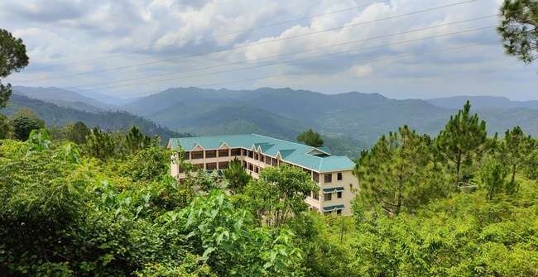

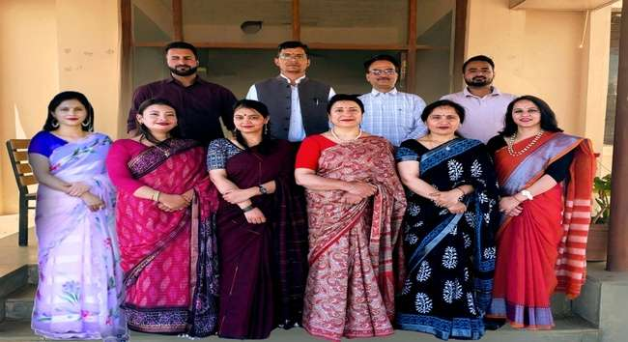

Tel and Fax: 01795-278777 & 278244

e-mail:gcdiggal-hp@nic.in

[gcdiggal@rediffmail.com](mailto:gcdiggal@rediffmail.com)

Website: [www.gdcdiggal.in](http://www.gdcdiggal.in)

Dr. Harpreet Kaur (Principal)

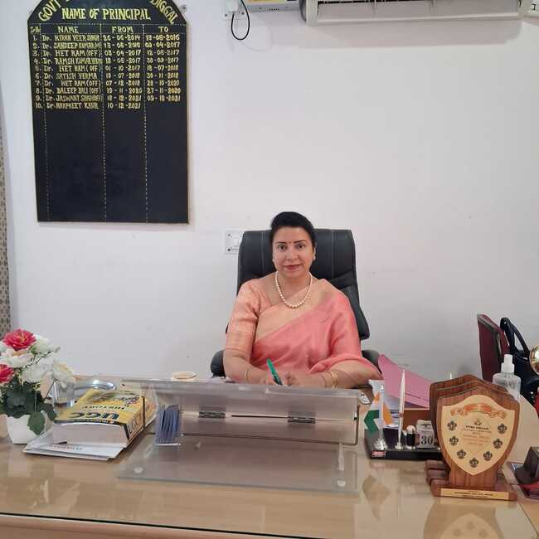

**Dr. Harpreet Kaur (Principal)**

***TEACHING FACULTY***

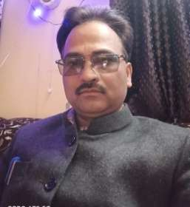 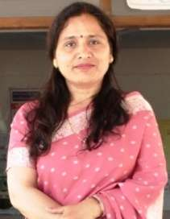 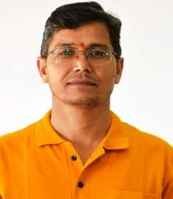 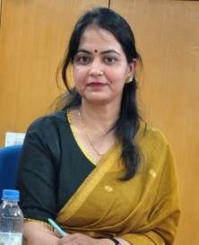 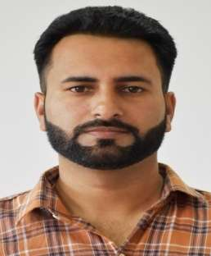

**Dr. Het Ram Dr. Sudershna Sharma Mr. Dharmender Kumar Dr. Sunita Sharma Dr. Naresh Kumar**

**(Music) (Mathematics) (History) (Hindi) (Commerce)**

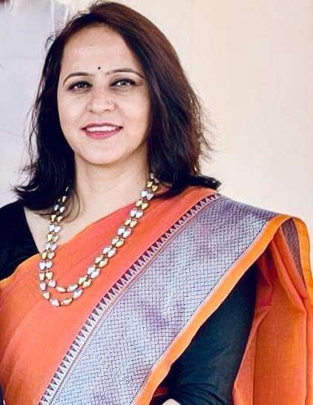 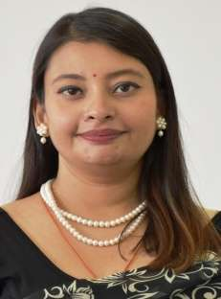 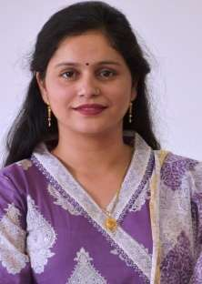 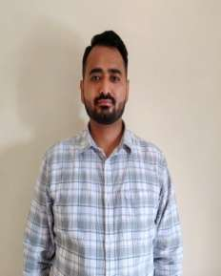

**Ms. Mamta Sharma Dr. Milanpreet Ms. Reenu Sharma Mr. Rahul**

**(Pol.Science) (Sociology) (Economics) (Commerce)**

***OFFICE/ADMINSTRATIVE STAFF***

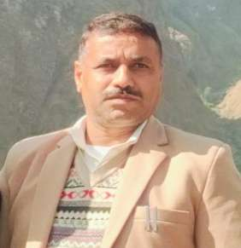 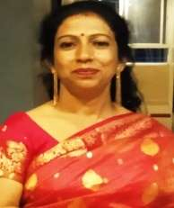

**Sh. Puran Thakur (Supdt. G-II) Smt. Anjana Devi (Asstt. Librarian)**

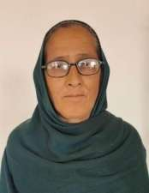 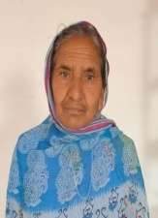 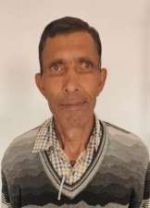 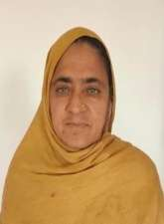 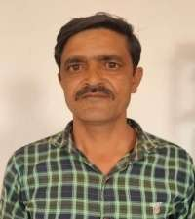

**Smt. Santosh Kumari Smt. Kamla Devi Sh. Chaman Lal Smt. Champa Devi Sh. Yash Pal**

Peon Peon Peon Peon Peon

***CONTENTS***

***Sr.No. Subject***

|  |
| --- |
| 1. Government Degree College Diggal : An Overview 2. Admission Details : Courses Offered in the College 3. Admission Schedule 4. New Pattern of CBCS-UGC(RUSA) : The Annual Pattern 5. National Cadet Corps (NCC) 6. National Service Scheme (NSS) 7. Arts (Humanities) Stream |
|  |
| 1. Important Guidelines for BA I Year |
| 1. Important Guidelines for BA II Year |
|  |
| 1. Roll-On Admission for Annual System Students (2024-25) |
| Important Guidelines for BA III Year |
| 1. Migration & Re-Appear |
| 1. Eligibility Criteria and Conditions : |
| Age-cum-Academic Parameters for BA/B.Com |
| 1. Admission Procedure |
| 1. Documents Required for Admission |
| 1. Reservation of Seats/Roster |
| 1. General Guidelines for Students |
| 1. Parent-Teacher Association ( The PTA Body) |
| 1. Fee & Funds 2. Academic Calendar |
| 1. Administrative Committees for the Session 2025-26 |

**Government Degree College Diggal : An Overview**

This College was notified by the State Government vide notification No. EDN-A-KHA (1)-1/2014 in January 2014 to promote and uplift the standard of Higher Education in the remote and rural pocket of district Solan. The institution became functional in June 2014 and imparts UG level education in eight subjects in Arts (Humanities) stream. The college was further academically enriched in June 2015 with the addition of Commerce Stream. Nurtured in the lap of lower Shivalik Hills, the College has a picturesque location, salubrious climate and a sound academic ambience.

**राजकीय महाविद्यालय दिग्गलः एक अवलोकन**

जिला सोलन के दूरस्थ एवं ग्रामीण क्षेत्र में उच्चतर शिक्षा के स्तर में सुधार एवं उत्थान हेतु राज्य सरकार की अधिसूचना क्रम संख्या EDN-A-KHA(1)-1/2014 के अंतर्गत जनवरी 2014 में राजकीय महाविद्यालय दिग्गल का आरंभ किया गया। जून 2014 में यह संस्थान व्यवहारिक रूप में आया तथा यहाँ स्नातक स्तर पर शिक्षा प्रदान करने हेतु मानविकी वर्ग में आठ विषयों की कक्षाएँ कार्यान्वित हैं। जून 2015 में वाणिज्य विषय जुड़ जाने से महाविद्यालय शैक्षणिक रूप से समृद्ध हुआ। यह महाविद्यालय शिवालिक की निचली पहाड़ियों में स्थित है तथा यहाँ का शैक्षणिक माहौल अति सुरम्य एवं स्वास्थ्यप्रद है।

**ADMISSION DETAILS**

**Courses offered in the College:**

The College offers UG ( B.A.) Course in Eight Subjects in the Faculty of Arts (Humanities) and UG (B.Com) course in the stream of Commerce, as per the CBCS-UGC(RUSA). From the academic session 2016-17 the Himachal Pradesh University has adopted this new pattern of education for higher studies i.e., CBCS-UGC (RUSA). This pattern of education was in the academic session 2017-18 and was adhered in the academic session 2018-19. However, from the academic session 2018-19 this CBCS-UGC(RUSA) pattern has become annual in structure and form. This Annual Pattern will be followed in the session 2025-26. Any further changes in this Annual Pattern of CBCS-UGC(RUSA) will be executed as per the directions and future notifications issued by the department of Higher Education, in consonance with the State Government.

**प्रवेश विवरण**

**महाविद्यालय में प्रस्तावित पाठ्यक्रमः-**

महाविद्यालय में स्नातक स्तर पर CBCS(UGC) के अंतर्गत पारित पाठ्यक्रम में, कला संकाय(मानविकी) में आठ विषय तथा वाणिज्य स्नातक(B.Com.) वाणिज्य संकाय में प्रस्तावित किए गए हैं। शिक्षा का यह नया स्वरूप CBCS(RUSA) अकादमिक स्तर 2016-17 में हिमाचल प्रदेश विश्वविद्यालय द्वारा अपनाया गया तथा 2017-18 और आगे भी इसी स्वरूप का अनुसरण किया गया। नई वार्षिक प्रणाली अकादमिक सत्र 2018-19 से आरंभ हुई तथा 2025-26 में भी यही प्रणाली लागू रहेगी। हिमाचल प्रदेश उच्चतर शिक्षा विभाग तथा हिमाचल सरकार के दिशा-निर्देशों तथा अधिसूचनाओं के अंतर्गत यह वार्षिक प्रणाली आने वाले सभी सत्रों में लागू रहेगी तथा किसी भी प्रकार का संशोधन समय-समय पर सूचित किया जाएगा।

**Note:** **I) *The students of B.A./B.Com 1st year have to register on digilocker/ABC portal after they have registered themselves with the University (HPU)***

II) ***If the New Education Policy is implemented for the students of 1st year students will be informed as per the new University notification.***

**Admission Schedule**

1. Submission of Admission forms for the session 2025-2026:- 01.06.25 to 19.06.25
2. Display of First Merit List:- 20.06.25 at 1.00 PM
3. Fee to be Deposited: 21.06.25 to 23.06.25
4. Display of second merit list: 24.06.25 at 11:00 AM
5. Fee to be deposited: 25.06.25 to 27.06.25 up to 5.00 PM
6. Admission timings: 10.00 AM to 2.00PM
7. Orientation of 1st year students: 28.06.25 to 30.06.25
8. Admission of UG 2nd and 3rd Year on Roll on Basis : 01.06.25-19.06.25
9. Fee to be Deposited: 12.06.25 to 23.06.25
10. Post admission Counselling: 24.06.25 to 23.06.25
11. Regular teaching work for all the classes: w.e.f. 01.07.25

**The New Pattern of CBCS – UGC (RUSA) Annual Pattern: Implemented w.e.f. the Academic Session 2018-2019 (For BA/BCom 2nd and 3 year)**

The Annual Pattern of CBCS-UGC (RUSA) was adopted for the UG Classes w.e.f. the Academic Session 2018-19 vide directions issued from the o/o the Secretary of Higher Education (HP) on dated 13th June, 2018 which were further duly endorsed from the Office of Registrar (Academic Branch) HP University, Shimla vide letter No.-7-1/2004-HPU(Acad) on dated 26thJuly,2018. .In course of executing this change of pattern (from Semester to Annual System) the following parameters came into force for the Annual System:

* + - The minimum passing marks will be 40% in Aggregate. However, 35% each in Internal Assessment and Final Examinations will be compulsory.
    - A candidate failing in either one or two subjects/papers will be given compartment in that subject/papers and will be eligible for promotion to the next class. He/She will appear in the subject/papers in which he/she got the compartment. He/She will have two chances (one at the supplementary stage and one at the annual stage), available to him/her to clear his/her compartment in subjects/papers. He/she will not be awarded the degree until he/she clears all his/her courses within five years from the date of his/her admission to a particular course.

#### A candidate failing in three or more subjects /papers will be treated as FAIL in that year and has to repeat the entire year.

* The successful candidates will be classified on the combined results of Part–I, II & III Examinations as per the following parameters :

First Division: 60% marks or more in the Aggregate

Second Division: 50% marks but less than 60%

Third Division: Less than 50% marks in the Aggregate.

* **Re-evaluation :**Re-evaluation shall be applicable as per provisions of HP University Ordinance for the Annual System.
* The students shall be required to complete the degree within five years.
* Final/Annual Examinations shall be held in the month of March/April every year and the Supplementary Examinations shall be held in the month of September/October every year.

अधिक एवं नवीनत्तम जानकारियों/संशोधनों के लिए हिमाचल प्रदेश सरकार के उच्चशिक्षा विभाग, हिमाचल प्रदेश विश्वविद्यालय शिमला और विश्वविद्यालय अनुदान आयोग की निम्नलिखित वैबसाईट पर लॉगइन किया जा सकता हैः

1. [www.hpuniv.gov.in](http://www.hpuniv.gov.in)
2. [www.hpuniv.in](http://www.hpuniv.in)
3. [www.hpuniv.hp.gov.in](http://www.hpuniv.hp.gov.in)
4. [www.ugc.ac.in](http://www.ugc.ac.in)
5. [www.educationhp.org](http://www.educationhp.org)
6. [www.exams.hpushimla.in](http://www.exams.hpushimla.in)

***National Cadet Corps (NCC):***

NCC Directorate Pb, Har & HP vide their letter No. 7701/Re-org/Sm/P&C dt. 30 Dec. 2020 approved NCC troop with cadet strength of 36 SD (Boys) and 18 SW (Girls) in Govt. Degree College Diggal.

***National Service Scheme (NSS)***

NSS Himachal Pradesh University, Shimla (NAAC Accredited “A” grade University) O/o Programme Coordinator, NSS vide their letter No.1/2009-(Allot)/NSS/HPU:-998 on dated 3rd January, 2023, allotted NSS half unit with volunteers strength of 50 in Govt. Degree College, Diggal.

***ARTS (HUMANITIES) STREAM: B.A.( Pass Course)***

# ARTS (HUMANITIES) STREAM: B.A.(Pass Course)

**Important Guidelines / Pattern / Scheme of Papers for B.A.Ist Year Students (Session 2025-2026 Batch) {on hold till new instructions}**

# Subject Structure of B.A.II (Session 2025-26)

|  |  |  |  |  |  |
| --- | --- | --- | --- | --- | --- |
| **Year** | **Core Courses** | **Ability Enhancement**  **Compulsory Courses (AECC)** | **Skill Enhancement Courses**  **(SEC)** | **Discipline**  **Specific Elective (DSE)** | **General**  **Elective (GE)** |
| **B.A.II**  **Pass Course** | English-II Hindi-1I DSC-1C DSC-1D DSC-2C DSC-2D  **Total 6x6= 36 Credits** | **NIL** | SEC-1 SEC-II  **Total 2x4=08 Credits** | **NIL** | **NIL** |

**Important Guidelines/Pattern/Scheme of Papers for B.A.III**

1. The Students seeking roll-on admission to B.A.III Year will have to study **Two DSE Subjects**, i.e, **DSE-I and DSE-II (Discipline Specific Electives)**, based on their two DSC subjects. Whereby the two DSC Subjects opted by the students at the time of their admission to the B.A. Course in the first year will continue to remain the two DSE Subjects for them in the final year.
2. The **Students of III year** will also continue to study **two SEC Course** that they had initiated from

B.A.II year of their course onwards.

c) In addition to the aforementioned three subjects the students will study two paper of **Generic Elective GE-I and GE-II.**

## Note : (Generic Elective Course) The Generic Elective in the ﬁnal year

***required to be offered by the student will be other than the two Discipline Speciﬁc Courses offered by the student.***

**Subject Structure of B.A.III Year (Session 2025-26)**

|  |  |  |  |  |
| --- | --- | --- | --- | --- |
| **Core Courses** | **Ability Enhancement Compulsory Courses (AECC)** | **Skill Enhancement Courses**  **(SEC)** | **Discipline Specific Elective (DSE)** | **General Elective (GE)** |
| NIL | NIL | SEC-III  Total 1x4=04 Credits  SEC-1V  Total 1x4=04 Credits | DSE-1A DSE-2A  Total 2x6=12 DSE-1B DSE-2B  Total 2x6=12 | GE-1  Total 1x6=06 GE-1I  Total  1x6=06 |

\**The students of B.Com 1stYear will have to study* ***two compulsory language papers****: English and Hindi. The details of these papers /courses are as under:*

|  |  |  |  |  |
| --- | --- | --- | --- | --- |
| Sr.No. | Compulsory Subject | Course Code | Year of Study | Nature of Course |
| 1 | English-1 | ENG CE 101 | 1*st* Year | Compulsory/Core |
| 2 | प्रयोजनमूलक हिंदी | HIND101 | 1st Year | MIL-I/HINDI-I Core |

*\*The students of B.Com 1st Year will also have to study* ***One AECC Language Course/Paper*** *from the two language papers (English or Hindi) given below &* ***Environment Science*** *will be a* ***Compulsory Course/Paper for all*** *:*

|  |  |  |  |  |
| --- | --- | --- | --- | --- |
| Sr.No. | Compulsory  Subject | Course Code | Year of Study | Nature of  Course |
| 1 | English(Writing  Skills) | ENG AECC 104 | 1st Year | AECC-2 |
| 2 | Environment  Science | ENVS2AECC02 | 1st Year | AECC |
| 3 | हिंदी भाषा और संप्रेषण | HIND104 | 1st Year | AECC |

*\*****These AECC (Ability Enhancement Compulsory Course) courses, i.e, English/Hindi/MIL Communication and Environment Science will be of 04 Credit Weightage each and these AECC subjects will be ﬁnalized by the college Admission Committee at the time of admission.***

**Migration:** Inter-institutional Migration (either from one college to another or from a college to ICDEOL and vice- versa) of students will be allowed as per HPU norms and will accrue only after obtaining **No- Objection Certificate from both the Relieving and Receiving Institutions.**

**Re-Appear (2nd &3rd Year):** If a student, who fulfils all the requirements for appearing in a Yearly examination, is unable to appear in the examination or to complete it on account of his/her own serious illness, accident, or on account of the death of near relative (Mother, Father, Brother and Sister), or due to the clash of dates of State or National level examinations falls on dates of the semester exams may be allowed to appear in the Yearly exam in the next Academic Year when examination for that year is due. Permission to sit in the examination will be granted by college Principal/Director on the production of a valid certificate/document from the competent authority. The college will send the names of the students to the Registration and Migration Cell for information.

# Eligibility Criteria and Conditions:

1. **AGE**: A candidate should not be more than 23 years of age (for Boys) and not of more than 25 years of age (for Girls) as on **01 July, 2025.** However, for SC/ ST candidates a relaxation of three years in age is allowed.
2. The Vice-Chancellor of H.P.U. may in exceptional cases/circumstances, to be recorded in writing,

give relaxation in age up to a maximum of six months to any candidate. All such cases of age relaxation of up to six months may be granted admission provisionally by the Principal and a consolidated list of all such cases will be sent for the approval of the Vice- Chancellor, HP University Shimla for every academic year.

1. Relaxation in upper age limit is also available to.

**Admission to B.A.Ist Year: : (On hold till new instructions)**

1. Candidate seeking admission to **B.A. 1st year** must have secured 33 percent marks at 10+2 level or equivalent examination **(Clear Cut Pass).**
2. The candidate who has passed or cleared all the five subjects including English from N.O.S is eligible to take admission in B.A.1st year.(c) Further a student taking admission to B.A. 1st year with Mathematics as one of the subjects should

have secured either 45% marks in aggregate or 45% in Mathematics at 10+2 level.

# Admission to B.Com IstYear: (On hold till new instructions)

# Admission Procedure:

***STEP-I :*** *Every candidate seeking admission shall apply for admission on the prescribed Admission Form that is available in the college prospectus. The Admission Form should be lled legibly by each candidate in his or her own handwriting.*

***STEP-II :*** *A candidate seeking admission should personally appear before the concerned Admission Committee along with the required original and certified documents and he/she must also be accompanied by Parents/Guardian at the time of admission.*

***STEP-III*** : *After the approval of the Admission Form by the Admission Committee it would be forwarded to the Scrutiny Committee and finally the admission to the college would be granted on merit- basis and on the recommendation of the Principal. The Principal, however, reserves the right to disallow or cancel any admission if the conduct of the student has not been up to the mark during previous years.*

*S****TEP-IV*** : *If the admission of the candidate is approved / recommended by the Principal, the candidate shall have to deposit the fee/ dues as per the instructions displayed on the college notice board. The number of seats is maximum 80 in each DSC subject and these seats will be filled on the* ***Basis of Merit*** *in each of the DSC subjects respectively. The students are advised to deposit their fee and funds within time after consulting the merit list that would be displayed on the college notice board.*

***STEP-V*** : *After depositing the fee the candidate will seek the enrolment of the college as a regular student. The admission will however remain* ***PURELY PROVISIONAL*** *in nature unless it is approved by HP University.*

# Documents Required for Admission:

**The candidates must submit/produce the following documents along with legibly and completely filled up Admission Form:**

1. **Original Certificates (along with their photocopies) Matric onwards.**
2. **Three passport size photographs.**
3. **Original Character Certificate issued by the institution last attended (for new admissions**

**/fresh candidates only)**

1. **An Affidavit issued by a Competent Authority in case of gap.**
2. **Category Certificate for SC/ST/Specially Abled students.**
3. **Sports and Cultural Certificates (if seeking admission under the Sports/ Cultural Quota).**
4. **Board equivalence Certificate for the candidates who have passed 10+2 from other Board/University than the H.P.Board. (HPBOSE). All such candidates (except H.P.Board candidates) will also have to produce original Migration Certificate from Board/ University from which they have passed the previous (last) examination.**
5. **Private students seeking admission to the College for the first time should submit recent Character Certificate issued by a Gazetted Officer/ MLA/ Pradhan of M.C./ Panchayat. (which shall be valid for six months)**
6. **Certificate of Bonafide Himachali (For girls students who belong to**

**Himachal). Only girl students who are Bonafide Himachali are eligible for exemption of tuition fees.**

1. **Copy of the Aadhar Card.**
2. **Copy of the Pass Book of Bank Account.**

**Note: *Submission of false information of any kind for the purpose of admission is a serious offence. Any such act will be viewed seriously and penal proceedings can be initiated against such candidates/ such offenders. The admission of such candidates shall also stand cancelled instantaneously.***

## Reservation of Seats: *Admission to UG courses shall be open to all persons irrespective of race, creed, caste or class subject to the conditions laid down in the Roster issued/notified by the H.P.U.*

**Point-1** The candidates seeking admission under any category or quota mentioned in the Roster, i.e., SC, ST, Specially abled, Sports or cultural, will have to produce the original certificate, issued by a Competent Authority, of his/ her category or quota at the time of admission to get the benefit of reservation.

**Point-2** The reservation roster issued/ notified by the HPU:

|  |  |  |  |  |  |
| --- | --- | --- | --- | --- | --- |
| SPECIALLY ABLED | CULTURAL | SPORTS | SC | ST | EWS |
| 03% | 05% | 05% | 15% | 7.5% | 10% |

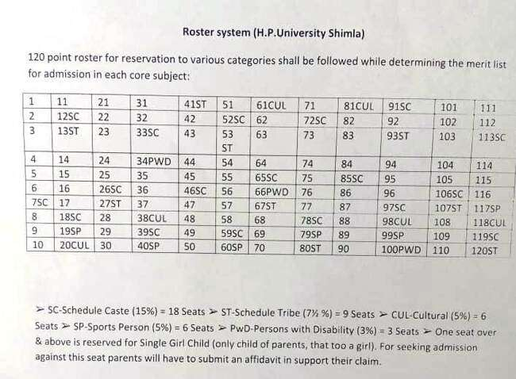

**STUDENT EVALUATION SYSTEM (for B.A./B.Com 2nd and 3rd year)**

#### UNDER-CBCS-UGC-(RUSA)-Annual System ( 2025-2026) :

The Student Evaluation System under CBCS of RUSA (Annual System) has been divided into two components:

Continuous Comprehensive Annual/Final Examination Assessment (CCA)

(30 Marks: For all courses) (70 Marks: For all courses)

**Continuous Comprehensive Assessment (CCA):**

It includes : (i) **Class Room Attendance** (05 Marks): A student must attend a minimum of 75% lectures/ tutorials failing which he/ she will not be eligible for appearing in the End Semester Examination of HPU

1. **Mid Term Test** (MTT) and a **Class Test** [10 + 05 = 15 Marks]

Mid –Term Test will be of 10 marks and the Class Test will be of 05 Marks for the students (in each Academic Year)

1. **Seminars/ Assignments/ Presentation/Tests and Tutorials** (10 Marks)

The above mentioned activities will be conducted by the teachers on regular basis during the Academic Year and the students will be awarded/grade according to their performance in these class-room activities.

A**NNUAL EXAMINATION: (70 MARKS)**

It refers to the examination conducted by the HPU at the end of the Academic Year. The Annual Examination will be based on the whole syllabus and will be of 03 hour duration.

**NOTE :** *(i) Only those students will be allowed to appear in the Annual Examination who have pass marks in CCA.*

*(ii) HPU may from time to time revise and amend (change) the regulations and curriculum after due approval of different bodies and authorities of the HP University.*

**GENERAL GUIDELINES FOR STUDENTS:**

1. *Change of Subject :* The students/ applicants are advised to be very careful while selecting and

filling their DSC subjects and SEC subjects. These subjects once opted will not be changed under any circumstances. The DSC-1 subject opted by the student at the time of admission in the first year will remain his/her SEC subject from 2nd and 3rd year.

1. *Re-Admission :* The name of the student who remains absent from any class for 10 continuous days, without proper leave, shall be struck-off from the college- rolls. However, the Principal, in his/her discretion, may re- admit such student on payment of the re-admission fee along with fine. The re- admission should be taken within four days of the name being struck- off failing which he/she will not be eligible for admission. Any student whose name is struck- off for the second time in a session will not be eligible for re- admission except in exceptional circumstances.
2. *Leave Rules :* Students applying for leave shall get their application recommended /approved from the concerned Subject Teacher. Leave up to a period of 6 days will be sanctioned by the concerned Teacher and leave for more than 6 days will be sanctioned by the Principal. Absence without leave would entail absence ne at the following rates:
3. Absence per Period = Rupee1/period
4. Absence from MTT-I/ MTT-II exams = Rs.50/ paper
5. ***Notice Board and Identity Card****:* Every student is advised to carry his/her college identity card while coming to the institution. It is also advisable to read the notices pasted/affixed on the college Notice Board on regular basis to keep upto date information about the college activities.
6. *Discipline:* Discipline is the key of student life and the institution expects high standards of orderliness from its pupil/subjects. The following activities will be considered as violation of the college discipline and may result in ne, expulsion or rustication, depending on the gravity of the offence:
7. Indulging in acts of Ragging and Eve - teasing.
8. Making noise, disturbing classes and using mobiles within the college campus.
9. Damaging college furniture/ property and writing on walls, furniture and blackboards.
10. Bringing outsiders to the college campus without any justifiable cause.
11. Any student found smoking or consuming other tobacco products in the college premises will be dealt sternly with.

**Note**: *A student found guilty of misconduct shall not be eligible for prizes, scholarships, fee- concession or membership of the CSCA (College Student Central Association), Sports Council or other important bodies of the College.*

**PARENT- TEACHER ASSOCIATION (The PTA Body):**

Since 2014, the college has framed a PTA for co-ordinated efforts of Parents and College Administration and for the betterment of the institution thereof. Fresh PTA will be constituted in the month of August 2021 as per the PTA norms laid down by the Education Department of H.P. Government. The Annual PTA fee for the session 2023-24 shall finally be decided after by PTA General House.

**Academic Calendar 2025-2026**

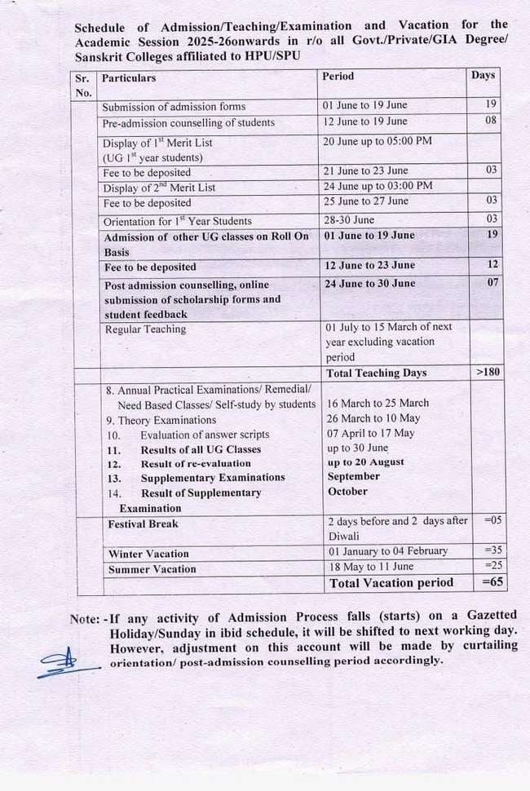

**FEE and FUNDS**

DETAIL OF FEE STRUCTURE FOR UNDER GRADUATE CLASSES(Annual System)

|  |  |  |  |
| --- | --- | --- | --- |
| SR. No. | Name of Fund | Amount  Rs | Periodicity |
| 1. | Admission fee | 25-00 | Annual |
| 2 | Re-Admission Fee first time | 100-00 |  |
| 3 | Re-Admission Fee second time | 200-00 |  |
| 4 | Late Admission Fee | 10-00 | Per day |
| 5. | Tuition Fee Rs .50 (PM for Boys and Non-Himachali Girls) | 600-00 | Annual |
| 6 | Continuation Fee (for 2nd & 3rd year students) | 10-00 |  |
| 7 | **HP Youth Welfare Fund** | **15-00** | **Annual** |
| 8 | **HPU Sports Fee** | **15-00** | **Annual** |
| 9 | **HPU Holiday Home fee** | **1-00** | **Annual** |
| 10 | **University Development Fund (General Students)** | **250-00** | **Annual** |
| **University Development Fund (BPL/IRDP Students)** | **100-00** | **Annual** |
| 11 | **CSCA Fund** | **10-00** | **Annual** |
| 12 | **Red Cross Fund** | **40-00** | **Annual** |
| 13 | Sports Fund | 240-00 | **Annual** |
| 14 | Building Fund | 120-00 | **Annual** |
| 15 | Amalgamated Fund | 300-00 | **Annual** |
| 16 | Rovers & Rangers Fund | 60-00 | **Annual** |
| 17 | Book Replacement | 25-00 | Annual |
| 18 | House Exam fees | 50-00 | Annual |
| 19 | College Magazine | 50-00 | Annual |
| 20 | Identity Card (First Time) | 10-00 | Annual |
| 21 | Identity Card (Duplicate) | 20-00 | Annual |
| 22 | Medical Fund | 06-00 | Annual |
| 23 | Student Aid Fund | 02-00 | Annual |
| 24 | Campus Development Fund | 10-00 | Annual |
| 25 | Furniture Replacement | 10-00 | Annual |
| 26 | Cultural Activities | 20-00 | Annual |
| 27 | Computer/Internet Facility | 20-00 | Annual |
| 28 | Library Security(Refundable) | 100-00 | Annual |
| 29 | Music/Commerce/ Maths (Practical Fee) | 180-00 | Annual |
| 30 | NCC Fund | 10-00 | Annual |
| 31 | PTA Fund | 500-00 | Annual |

**Note:** The fee and fund structure given above is subject to change as per the directions/ guidelines issued by the competent authorities from time to time.

**Administrative Committees for the Academic Session 2025-26**

1. **CSCA Committee:**

Dr. Het Ram (Convenor)

Dr. Sudershna Sharma

Mr. Dharmender Kumar

Dr. Sunita Sharma

1. **Prospectus Committee/Management Cell:**

Dr. Sudershna Sharma(Convenor)

Dr. Sunita Sharma

Dr. Naresh Kumar

Dr. Milanpreet

Mr. Puran Thakur

1. **Time Table Committee:**

Dr. Sudershna Sharma(Convenor)

Dr. Sunita Sharma

Dr. Naresh Kumar

1. **RUSA/ NAAC/University Affairs/ UGC /Examination Cell**

Dr. Het Ram (Co-ordinator)

Dr. Sunita Sharma

Dr. Naresh Kumar

Ms. Mamta Sharma

Dr.. Milanpreet

1. **College Property Committee:**

Mr. Dharmender Kumar (Convenor)

Dr, Naresh Kumar

Ms. Reenu Sharma

Mr. Puran Thakur

1. **Anti-Ragging/ Discipline Committee:**

Dr. Sudershna Sharma (Convener)

Mr. Dharmender Kumar

Dr. Naresh Kumar

Mr. Rahul

Mr. Puran Thakur

1. **Anti-Ragging Squad**

Dr. Naresh Kumar

Ms. Mamta Sharma

Mr. Rahul

1. **Women Grievances Committee:**

Dr. Sudarshana Sharma (Chairperson)

Dr. Sunita Sharma

Ms. Mamta Sharma

Mr. Rahul

Ms. Anjana Devi (Asstt. Librarian)

Smt. Champa Devi

One female member from PTA

1. **Purchase Committee:-**

Dr. Het Ram (Convener)

Mr. Dharmender Kumar

Dr. Naresh Kumar

Mr. Puran Thakur

1. **College Magazine Committee:**

Dr. Het Ram (Chief Editor)

Dr. Sudershna Sharma (English Section)

Dr. Dharmender Kumar (Pahari Section)

Dr. Sunita Sharma (Hindi Section)

Ms. Reenu Sharma (Planning Section)

1. **Computer/ Electric Appliances Committee:**

Dr. Sunita Sharma (Convener)

Dr. Naresh Kumar

Ms. Reenu Sharma

Mr. Puran Thakur

1. **Red-Ribbon**

Dr. Sunita Sharma (Convenor)

Ms. Mamta Sharma

Ms. Reenu Sharma

1. **Eco Club**

Dr. Sunita Sharma (Convenor)

Ms. Mamta Sharma

Ms. Reenu Sharma

1. **Scholarship and Financial-Aid Committee:**

Dr. Het Ram (Convenor)

Dr. Sudershna Sharma

Ms. Mamta Sharma

Dr. Milanpreet

Ms. Reenu Sharma

1. **Attestation and Bus Pass Committee**:

All the staff members (Teaching)

**(XIV) College Advisory Committee:**

Dr. Het Ram (Convener)

Dr. Sudershna Sharma

Mr. Dharmender Kumar

Mr. Puran Thakur

**(XV) Career Counselling and Placement Cell:**

Dr. Harpreet Kaur (Head of CC & PC)

Dr. Sudershna Sharma (Deputy Head)

Dr. Naresh Kumar (Rusa Co-ordinator)

**(XVI) Cultural Activities Committee:**

Dr. Het Ram (Convenor)

Dr. Sunita Sharma

Ms. Mamta Sharma

Dr. Milanpreet

Ms. Reenu Sharma

**(XVII) Educational Tour/Picnic/Excursion Committee:**

Dr. Sunita Sharma (Convenor)

Dr. Naresh Kumar

Ms. Mamta Sharma

Dr. Milanpreet

Ms. Reenu Sharma

**(XVIII) Sports Club:**

Mr. Dharmender Kumar (Convenor)

Dr. Naresh Kumar

Mr. Rahul

Mr. Puran Thakur

**(XIX) Road Safety Club**

Mr. Dharmender Kumar (Convenor)

Ms. Mamta Sharma

Ms. Reenu Sharma

**(XX) College Bursar**

Mr. Naresh Kumar

(XXI) **Anti Drug Club/ Drug Prevention Committee**

Dr. Milanpreet

Dr. Sunita Sharma

Ms. Mamta Sharma

(XXII) **Anti-Drug Squad**

Mr. Dharmender Kumar

Dr. Naresh Kumar

Mr. Rahul

(XXIII) **AISHE Incharge**

Mr. Naresh Kumar

**(XXIV) NCC Incharge**

Dr. Naresh Kumar

**(XXV) NSS Incharge**

Mr. Rahul

**(XXVI) Redressal of Grievances of students**

Dr. Sudersna Sharma

Dr. Sunita Sharma

Ms. Mamta Sharma

Mr. Rahul

Member of CSCA

**(XXVII) House Examination Committee**

1. Dr. Sunita Sharma (Convenor)
2. Dr. Naresh Kumar
3. Ms. Mamta Sharma
4. Ms. Reenu Sharma

**(XXIII) IQAC**

1. Principal Dr. Harpreet Kaur (Chairperson)
2. Dr. Het Ram (Co-ordinator)
3. Dr. Sudershna Sharma (Deputy Co-ordinator)
4. Dr. Milanpreet
5. PTA President
6. Mr. Puran Chand (Supdt.)
7. Two Student member (CSCA)

**(XXIV)Library Committee**

Dr. Sudershna Sharma

Ms. Mamta Sharma

Ms. Anjana Devi

Mr. Puran Thakur

**(XXV)College Sanitization Committee**

Mr. Dharmender Kumar

Ms. Mamta Sharma

Mr. Rahul

Mr. Puran Thakur

**ADMISSION COMMITTEE (Session-2025-26)**

**(For B.A.I,II & III Year Boys and Girls (For online Admission)**

Mr. Dharmender Kumar (Convenor)

Dr. Sunita Sharma

Ms. Mamta Sharma

Dr. Milanpreet

Ms. Reenu Sharma

**(For B.Com.I, II & III Year Boys and Girls (For online Admission)**

Dr. Naresh Kumar (Convenor)

Mr. Rahul

**(XXII) SCRUTINY COMMITTEE: For All Classes (BA/B.Com)**

1. Dr. Het Ram (Convenor)
2. Dr. Sudershna Sharma
3. Dr. Dharmender kumar

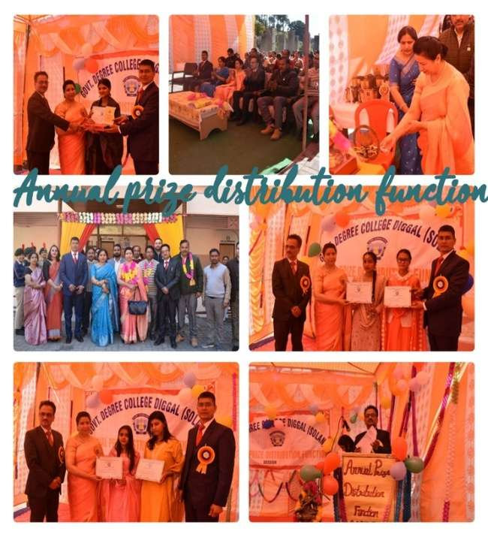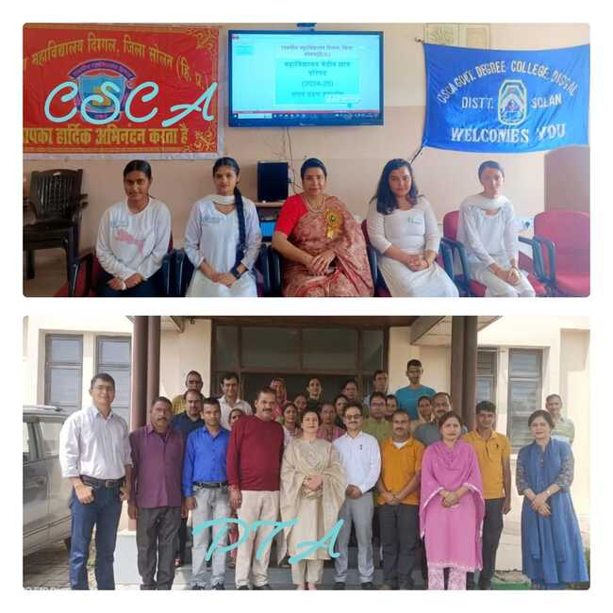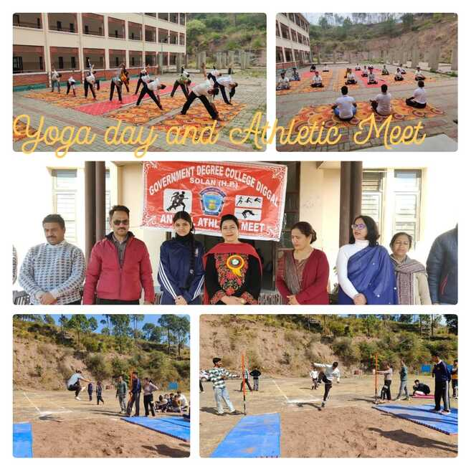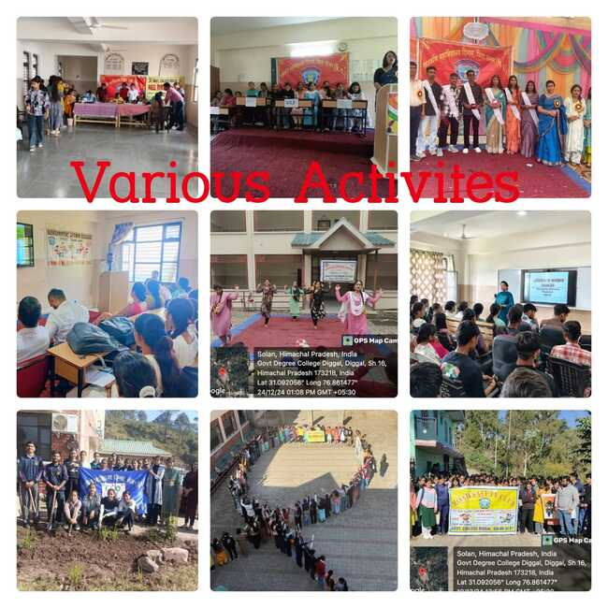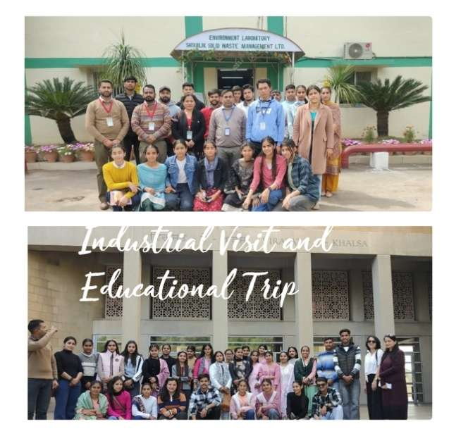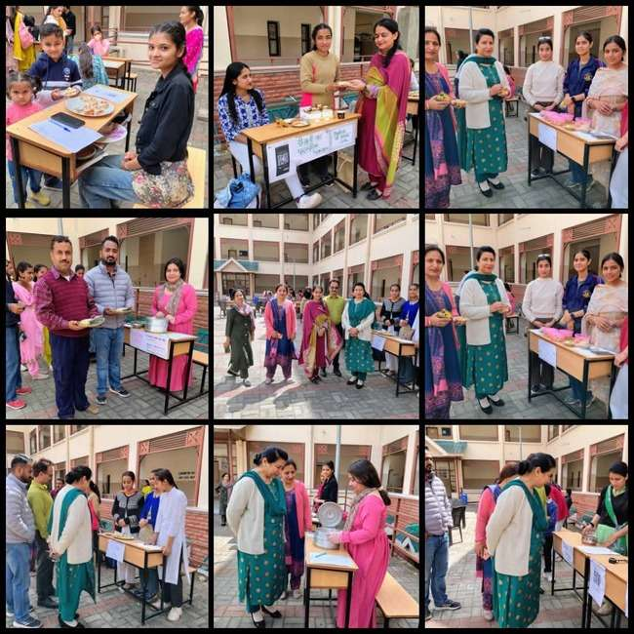

**Non-Teaching Staff Photo With Principal**

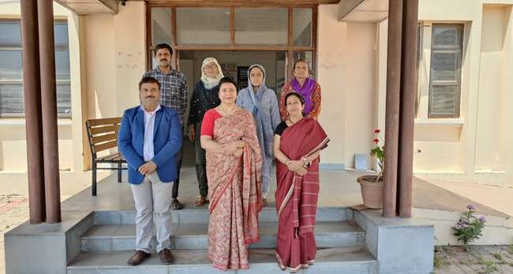

|  |
| --- |
| **Use of Mobile Phones is not allowed in the College Campus** |

|  |
| --- |
| **Use of Tobacco products and Alcohol is Prohibited in the College Campus.** |

Price 50/.

|  |
| --- |
| **RAGGING IS A CRIME** |

**Anti - Ragging- Notification & Warning**

**रैंगिग**/छात्रोत्पीड़न

मानसिक अथवा शारीरिक रूप से किसी व्यक्ति अथवा समूह द्वारा किसी भी छात्र/छात्रा का उत्पीड़न जिससे विद्यार्थी के मन में यह भय उत्पन्न हो जाए कि वह अपना अध्ययन उपयुक्त वातावरण में नहीं कर सकता, रैगिंग कहलाता है। किसी भी प्रकार का छात्रोत्पीड़न, महाविद्यालय अथवा उनकी ओर से आने वाले रास्ते पर पूर्ण रूप से वर्जित है। रैगिंग एक दंडनीय अपराध है। अगर कोई विद्यार्थी उत्पीड़न में संलिप्त पाया गया तो जांच-पड़ताल के उपरांत उसे यथोचित दंड दिया जाएगा , जिसमें महाविद्यालय से निष्कासन , 50000 रूपए तक जुर्माना और तीन वर्ष तक की कैद सम्मिलित है।

|  |
| --- |
| छात्राओं से छेड़छाड़ करना अपराध है। दोषी को तुरंत पुलिस के सुपुर्द किया जाएगा। |